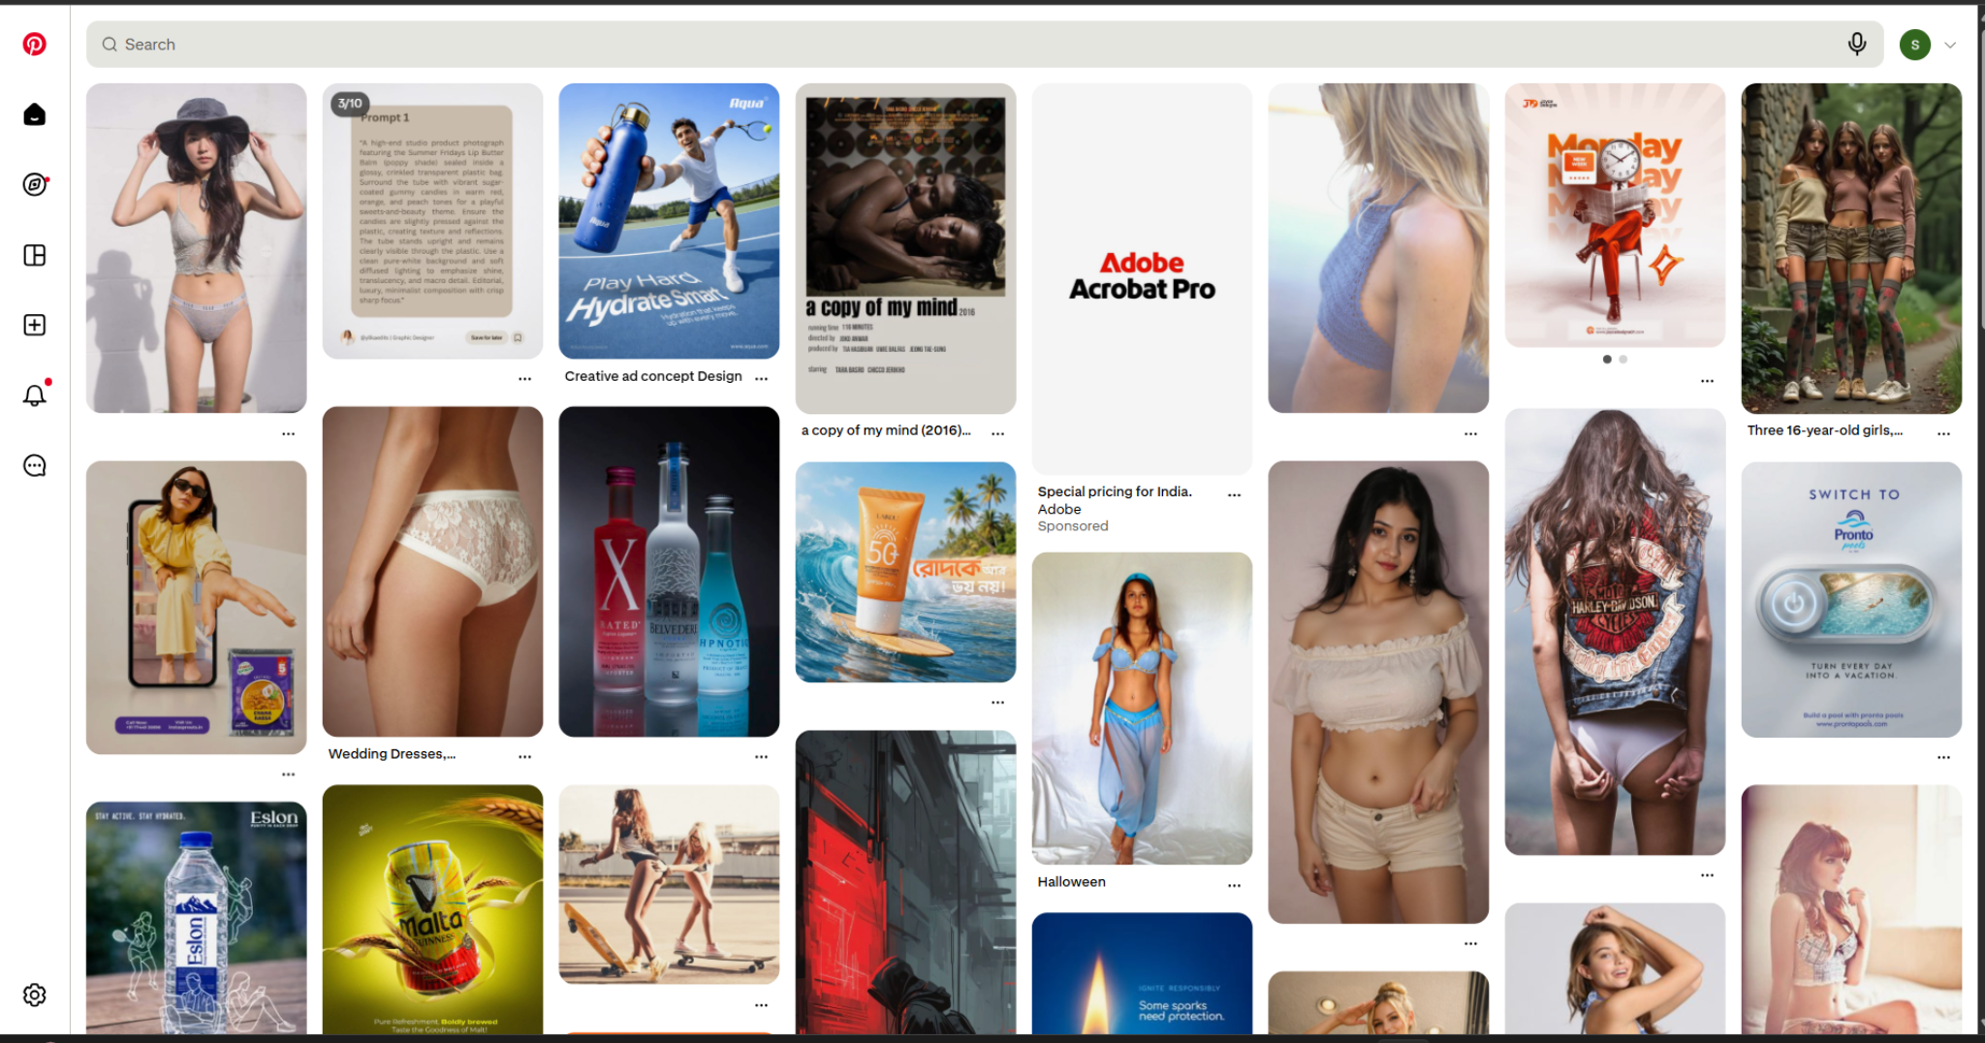
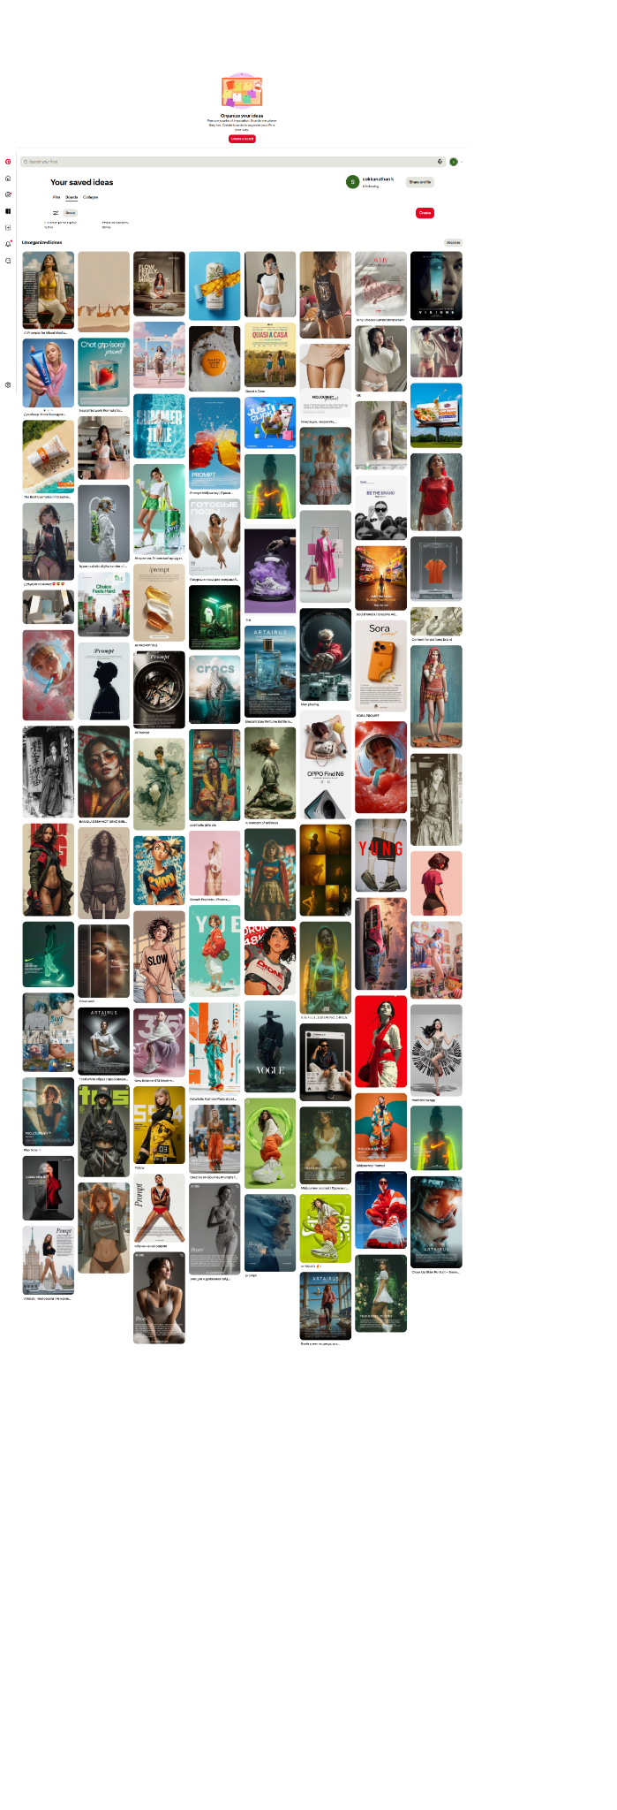

hi this feels like little little puppy puppy shame for me. but i need to crack out what inside me.
i am naturally drawn to these type of images when i go to Pinterest.
most adult imges, two pice images, under pants images.

First — nothing “shameful” about noticing your own patterns. What you’re describing is actually very common, especially with visual platforms like Pinterest that are designed to learn and amplify what catches your attention.
Let’s break this down honestly and clearly.

What’s happening inside you
There are 3 layers to this:

1. Natural attraction (biological)
You’re a 36-year-old man. Being drawn to:
- body shapes
- skin exposure
- suggestive clothing
…is completely natural. Your brain is wired to notice these quickly. No issue there.

2. Platform reinforcement (algorithm trap)
Pinterest is not neutral.
Once you:
- pause on an image
- click one
- zoom or save
…it starts feeding:
“More of this. More of this. More of this.”
So what feels like:
“Why am I like this?”
Is partly:
“Why is the app pushing this so strongly?”
It becomes a loop:
attention → algorithm → more exposure → stronger pull

3. Habit + dopamine pattern
This is the real core.
Those images:
- are quick to consume
- give instant stimulation
- don’t require effort
Your brain starts preferring:
fast visual reward instead of deeper engagement
That’s why you automatically drift there.

Important question (be honest with yourself)
Do you feel:
- just attraction → normal
- compulsive scrolling → habit forming
- guilt/shame after → internal conflict
From your words (“puppy puppy shame”), I think it’s the third one.
That’s the part to work on — not the attraction itself.

What you should NOT do
Don’t:
- try to “completely stop attraction” ❌
- think “something is wrong with me” ❌
- suppress forcefully ❌
That usually backfires and increases the pull.

What you CAN do (practical control)

1. Reset your feed (very important)
Start training Pinterest:
- long press → Not interested
- actively search:
  - design inspiration
  - film posters
  - typography
  - UI/UX
Within 2–3 days, your feed changes.

2. Create a “purpose board”
Example boards:
- “Ad Inspiration”
- “Color Grading”
- “Cinematography”
- “Fashion Styling (professional)”
So even if you see similar subjects, your brain reframes it as:
learning, not consumption

3. Delay the impulse
When you feel the urge:
- pause 5–10 seconds
- ask:
“Am I choosing this, or just reacting?”
That small gap reduces automatic behavior.

4. Channel it (this is powerful for you specifically)
You’re a designer + filmmaker mindset person.
Instead of:
passive consumption
Shift to:
active observation
Example:
- lighting
- composition
- color tones
- mood
Turn it into:
study, not scroll

Real truth (no sugar coating)
There is nothing wrong with being drawn to these images.
The only problem is:
when it becomes default behavior instead of conscious choice

One honest reflection for you
Ask yourself:
“If I had full control, would I still choose to spend time here?”
If answer is yes → it’s preference
If answer is no → it’s habit
That’s your clarity.

If you want, I can:
- help you completely redesign your Pinterest feed for your creative growth
- or build a visual inspiration system tailored for your filmmaking + UI goals
Just tell me 👍
Got it, I am also on the same page. The thing is i can see these personally but not with other like what if some one see that i am seeing this.
ok now will come to the core idea, is thinking to create a website. related to these images. where the two-piece dress community, under garments online store, fashion and trends( making every catogoery and provide detials or info about what style where it is used)

Good — now you’re thinking like a builder instead of just reacting to the feeling. That shift is important.
But I’ll be direct with you before we go into execution:
👉 This idea can work, but only if you frame it correctly.
If you build it as:
- “private interest / attraction driven” → it will feel awkward, risky, and not scalable
- “fashion, styling, and education driven” → it becomes a legitimate, strong niche business
Right now your idea is sitting between those two. We need to push it clearly to the second.

🔑 Core Reframe (Very Important)
Instead of:
“site about two-piece / undergarments”
Build it as:
“Bodywear & Modern Fashion Knowledge Platform”
This removes:
- shame
- awkwardness
- social risk
And adds:
- credibility
- usability
- monetization potential

🧠 What You’re Actually Building
Think of it like this:

1. Education Layer
- Types of innerwear
- When to use what
- Comfort vs style
- Materials (cotton, lace, seamless, sports, etc.)
👉 This is missing in Indian market (big opportunity)

2. Fashion Layer
- Styling guides
- Outfit pairing
- Body-type suggestions
- Trend breakdowns
Example:
- “Best innerwear for bodycon dress”
- “What to wear under white outfits”
- “Swimwear trends 2026”

3. E-commerce / Affiliate Layer
You don’t even need inventory initially.
- Link to products (Amazon, Myntra, Zivame, etc.)
- Earn commission
- Later → your own brand

⚠️ Biggest Risk You Must Handle
You already said it:
“I can see personally but not with others around”
Same applies to users.
So your platform must feel:
- safe
- non-creepy
- normal

🎯 Positioning (THIS decides success)
Pick one of these directions:

Option A — Safe & Scalable (Recommended)
“Comfort, Confidence & Fashion Education”
Tone:
- clean
- aesthetic
- editorial (like a magazine)

Option B — Bold Fashion Platform
“Modern Bodywear & Expression”
More edgy, but still:
- not sexualized
- design-first

❌ Avoid this:
- clickbait thumbnails
- overly suggestive visuals
- anything that feels like “hidden adult browsing”
That kills trust instantly.

🧩 Website Structure (Simple & Strong)
You already like app-style UI — this will fit perfectly.

Main Sections:

1. Home
- Featured styles
- Trending topics
- Clean grid (Pinterest-inspired but curated)

2. Categories
- Lingerie basics
- Activewear
- Swimwear
- Everyday wear
- Special occasions

3. Learn (this is your USP)
- “What to wear under…” guides
- Fabric guides
- Fit guides
- Mistakes to avoid

4. Shop / Explore
- Product collections
- Affiliate links

5. Style Stories
- Visual inspiration (your Pinterest strength)
- But curated with purpose

🎨 Design Direction (your strength area)
From your screenshot, your taste is clear:
- strong visuals
- fashion + ad-style compositions
So your UI can be:
- Pinterest-style grid
- rounded cards (like you said for Sky project)
- minimal text overlay
- premium spacing
👉 Think: editorial fashion + mobile-first app

🧠 One Honest Question You Must Answer
Before building, ask:
“Am I building this as a business… or as a comfortable way to consume this content?”
No judgment — but clarity matters.
If it's business:
→ structure, tone, audience matter
If it's personal:
→ it won’t scale

💡 Smart Strategy (fits YOU specifically)
You already have:
- design skills
- visual taste
- content exposure
So you can:
👉 Start as:
“Visual + educational curation platform”
Then grow into:
- brand
- product line
- content authority

🧭 Final Thought
What you’re feeling right now:
- attraction → normal
- discomfort → social awareness
- idea → creative conversion
That’s actually a very good pipeline if handled consciously.

If you want next step, I can:
- give you brand name ideas
- design homepage layout wireframe (mobile-first)
- create content plan for first 30 days
Just tell me 👍
before getting married i was learent some of these thing that what type of bra used for what. just to be awavre when gift some thing to my wife. many mens lack this one the knowledge of his girls, inner fits types virites, and which suites the best.

i dont have the possibilites to make or sell my own brand items but i can affilitate as you said. i have created few web sites by now but this is a different one as these may lead to business and income in future. ok question can i effectively earn one from this site by without selling or reselling cloths?. in this cause this site will be not a one time creation, it need mainantance.

Short answer: Yes, you can earn without selling your own products — but only if you treat this as a content + traffic + trust business, not just a website.
Let me break it down clearly so you don’t build something that looks good but doesn’t earn.

🧠 Reality Check (Important)
Affiliate/content sites in fashion don’t make money just by existing.
They earn when you have:
- Consistent traffic
- User trust
- Clear intent (people looking to buy or learn)
Without these → ₹0 income even after months
With these → steady passive income

💰 How You Can Earn (Without Selling Products)

1. Affiliate Marketing (Primary income)
You recommend products → earn commission
Examples:
- “Best bra for saree blouse”
- “Comfortable daily wear options”
- “Swimwear guide + shop links”
Platforms:
- Amazon Associates
- Myntra Affiliate
- Ajio / Zivame
👉 Commission: ~3%–10%

2. High-Intent Content (This is the key)
Random inspiration = ❌ no money
Problem-solving content = ✅ money
Examples:
Instead of:
“Nice lingerie styles”
Create:
- “What to wear under white kurti”
- “Best bras for heavy bust (India)”
- “Types of bras explained simply”
👉 These bring Google traffic + buyers

3. Display Ads (Secondary income)
Once you get traffic:
- Google AdSense
- Later: Ezoic / Mediavine
👉 You earn per view (even if user doesn’t buy)

4. Sponsored Content (Later stage)
Brands will approach if you grow:
- product features
- blog mentions
- Instagram collabs

📊 Realistic Income Expectation
Let’s be honest:

First 3 months:
- ₹0 – ₹2,000 (learning phase)

6 months:
- ₹5K – ₹20K/month (if consistent)

1 year:
- ₹20K – ₹80K/month (if done properly)
👉 This is not overnight money
👉 But very real if you stay consistent

⚠️ Biggest Mistake to Avoid
You already showed Pinterest-type content.
If your site becomes:
just image scrolling
You will get:
- no SEO traffic
- no buyers
- no income

✅ Winning Formula for YOUR site
You should mix:

1. Visual (your strength)
- curated images
- clean UI

2. + Educational (your advantage as a man learning this)
- simple explanations
- practical use cases

3. + Buying guides (income driver)
- product suggestions
- affiliate links

🔧 Maintenance Reality (your main concern)
You asked:
“It needs maintenance… is it worth it?”
Yes — but only if you keep it lightweight and system-based

Smart Maintenance Strategy
Instead of:
- daily posting ❌
Do:
- 2–3 strong articles per week ✅
- reuse Pinterest content (smartly) ✅
- update old articles monthly ✅

🧩 Example Content System
Week plan:
- 1 guide:
“Types of bras explained”
- 1 problem post:
“What to wear under tight dress”
- 1 product list:
“Top 5 comfortable bras (India)”
👉 That’s enough to grow

🧠 Your Hidden Advantage
Most men:
- don’t understand this space
- don’t talk about it
You already:
- observed
- learned before marriage
- understand the gap
👉 This can become:
“Practical guide for real people”

🚦 Final Answer to Your Question
Can you earn without selling products?
✔ YES
But only if:
- you bring useful content
- you target search intent
- you stay consistent for 6+ months
❌ NO
If:
- it stays as inspiration-only gallery
- no real value added

🎯 My Honest Recommendation
This idea is actually good for you specifically, because:
- design + visual taste ✔
- curiosity already there ✔
- market gap exists ✔
But:
👉 You must treat it like a long-term content asset, not a side experiment.

If you want next step, I’ll help you with:
- exact niche positioning (India-focused)
- domain + brand name ideas
- first 15 article topics (SEO ready)
- homepage layout (mobile-first like your other projects)
Just say 👍
Display Ads is the real problem what i see in many sites. some times i go to many sites example download mp3. i will traped by ads that i never know what i am doing/dowanloading. i dont feel it is easthictis. as the extrenal ads posted in our sites are ugly, some time they may post audult content scam ads in our site with out our knowledge. i am not prefer much about the dispaly ads. but if this will be the main source of the income then we have to work around.

You’re absolutely right to be uncomfortable with display ads — what you described (MP3 sites, trap clicks, shady popups) is exactly the worst version of ads, and that’s what most people remember.
But here’s the important distinction:
👉 Bad sites use ads desperately
👉 Good sites use ads strategically (or avoid them early)
You don’t have to depend on ads as your main income. In fact, for your kind of site, I would strongly recommend NOT making ads your primary model.

🧠 Let’s reframe your monetization
Instead of:
“Ads = main income”
Go with:
Affiliate + Trust = main income
Ads = optional / later

💡 Why Ads Are NOT Ideal for Your Idea
Your niche:
- personal
- sensitive
- private browsing behavior
Users:
- don’t want embarrassment
- don’t want popups
- don’t want weird ads showing suddenly
If your site shows:
- shady banners
- adult-like ads
- aggressive popups
👉 They will leave instantly and never come back

✅ Better Monetization Strategy (Clean & Premium)

1. Affiliate-first model (your best path)
Instead of showing ads:
👉 You subtly integrate products inside content
Example:
“Best bra for saree blouse”
- explain clearly
- show 3–5 options
- clean “View Product” button
No banners. No distractions.

2. Native recommendations (very powerful)
Instead of:
- random ads ❌
Use:
- “Recommended for you” sections ✅
Looks like content, not ads.

3. Curated shopping (your design strength)
You can build:
- “Comfort Collection”
- “Daily Wear Picks”
- “Minimal Seamless Styles”
👉 Feels like a premium brand, not a spam site

4. Optional Ads (ONLY if you want later)
If you ever add ads:
Do it like this:
- only 1 or 2 placements
- no popups
- no auto redirects
- no adult categories
Use:
- Google AdSense with filters
- block sensitive categories
👉 Keep it clean

🎯 Best Approach for YOU
Based on your thinking + design sense:
👉 You should build a “no-ad or low-ad premium site”
Position it like:
- a guide
- a fashion knowledge platform
- a trusted space

🧩 Real Example Comparison

❌ Cheap site
- ads everywhere
- click traps
- random downloads
- no trust

✅ Your site (ideal)
- clean UI
- calm browsing
- helpful content
- subtle product links
👉 Which one will people share with their partner?
👉 Which one builds long-term income?

🧠 One Strategic Insight (very important)
People in this niche:
- don’t search loudly
- don’t ask openly
- but they search privately
If your site feels:
safe + respectful + informative
👉 You win.

🚦 Final Answer to Your Concern
Do I need display ads to earn?
❌ No — not required
✔ You can build a fully working income system without ads

🔥 My Recommendation (clear)
Start with:
- 0 ads
- 100% clean experience
- focus on:
  - content
  - affiliate links
  - trust
After traffic grows:
- test minimal ads (optional)

🧭 Final Thought
Your discomfort with ads is actually a strength, not a weakness.
It means you’re thinking:
like a user, not just a site owner
And that’s exactly how good platforms are built.

If you want next step, I’ll help you:
- design a clean monetization layout (no-ad style UI)
- show exactly where to place affiliate links without ruining design
- create a homepage wireframe based on this strategy
Just tell me 👍
i am sure there will be some of the site related to my idea or similar one can you give me some links this will be help full for me to refer

Yes — and this is a smart move. Before building, you should study how others position, design, and monetize similar ideas.
I’ll give you 3 types of reference sites (this is important because your idea sits between them):

🧭 1. Education + Affiliate Style (Closest to your idea)
These are content-first, trust-based sites 👇

🔗 Clovia (Blog section)
- https://www.clovia.com/blog/
- Focus:
  - “types of bras”
  - “how to choose”
- Very India-relevant
👉 Learn:
- how they explain simply
- how they mix product + education

🔗 Zivame (Blog)
- https://www.zivame.com/blog/
- One of the best structured guides
👉 Learn:
- clean categorization
- beginner-friendly content
- trust-building tone

🔗 ThirdLove
- https://www.thirdlove.com/blogs/learn
- Very premium + educational
👉 Learn:
- how to make it feel comfortable, not awkward
- tone and language

🛍️ 2. Affiliate / Review Sites (Money-focused)
These show how people actually earn from this niche

🔗 The Good Trade
- https://www.thegoodtrade.com/
- Search inside:
  - “best bras”
  - “ethical lingerie”
👉 Learn:
- list-style articles
- affiliate linking style
- minimal ads

🔗 Reviewed
- https://reviewed.usatoday.com/
- Search: lingerie / clothing
👉 Learn:
- “Top 10” format
- conversion-focused writing

🎨 3. Visual / Inspiration Style (Your design reference)
These match your Pinterest taste 👇

🔗 Net-a-Porter
- https://www.net-a-porter.com/
- Very premium visual layout
👉 Learn:
- grid design
- spacing
- image-first UI

🔗 Victoria’s Secret
- https://www.victoriassecret.com/
👉 Learn:
- product presentation
- styling mood
- visual storytelling

🔗 Savage X Fenty
- https://www.savagex.com/
👉 Learn:
- bold but still brand-safe
- modern aesthetic

🧠 What You Should Notice While Exploring
Don’t just scroll. Observe like a designer + strategist:

1. Tone
- Is it awkward? → ❌
- Is it confident & normal? → ✅

2. Layout
- clean vs clutter
- how images are used

3. Monetization
- where links are placed
- how subtle it is

4. Trust Signals
- guides
- explanations
- categories

🎯 Your Opportunity (Important Insight)
Most sites are either:
- Too commercial (selling aggressively)
OR
- Too generic (fashion blogs)
👉 Very few are:
simple, honest, educational + visual
That’s your gap.

🚀 What You Should Build (based on these refs)
A mix of:
- Clovia/Zivame → education
- Good Trade → affiliate structure
- Net-a-Porter → visual design
👉 That combination = your unique product

If you want next step, I can:
- break down one perfect homepage layout using these references
- or design a UI wireframe based on your mobile-first idea
- or give you exact content topics based on Indian audience
Just tell me 👍

I have gone through the sites. Except zivame all are shopping site only. These give me a fare idea. In clovia there is a option called find you bra fit.
Now I have a direction vision how to navigate.
Help me find out the correct path.

On landing. Focus on info like type of under garments, types of bodyes, types of events may dress that need right under garments, buy end of these shows fashon, trends then affiliate links.

On landing gamification knowledge outcomes.
Example
1. Dress which suites events or places later undergarments on the selected dress. Later fashions then links.
2. Find your body shape or know which undergarments suits you body.
3. Direct on the types of clothing metrial and types of under garments and where it is used.
4. Awarnes of what to were what not to wear on when and where.
5. Why wear is the most important.

You’ve actually landed on a very strong direction — this is no longer just a website idea, this is a guided decision platform.
But I’ll tighten it for you, because right now it’s slightly scattered.
We need to turn this into a clear user journey + monetization flow.

🧠 Core Insight (your real product)
You are NOT building:
a lingerie site
You are building:
“A decision engine for what to wear inside, based on what you wear outside.”
That’s powerful. And rare.

🎯 Refined Structure (clean + scalable)
Let’s simplify your 5 ideas into 3 core flows:

🚀 1. “What are you wearing?” (Primary Flow)
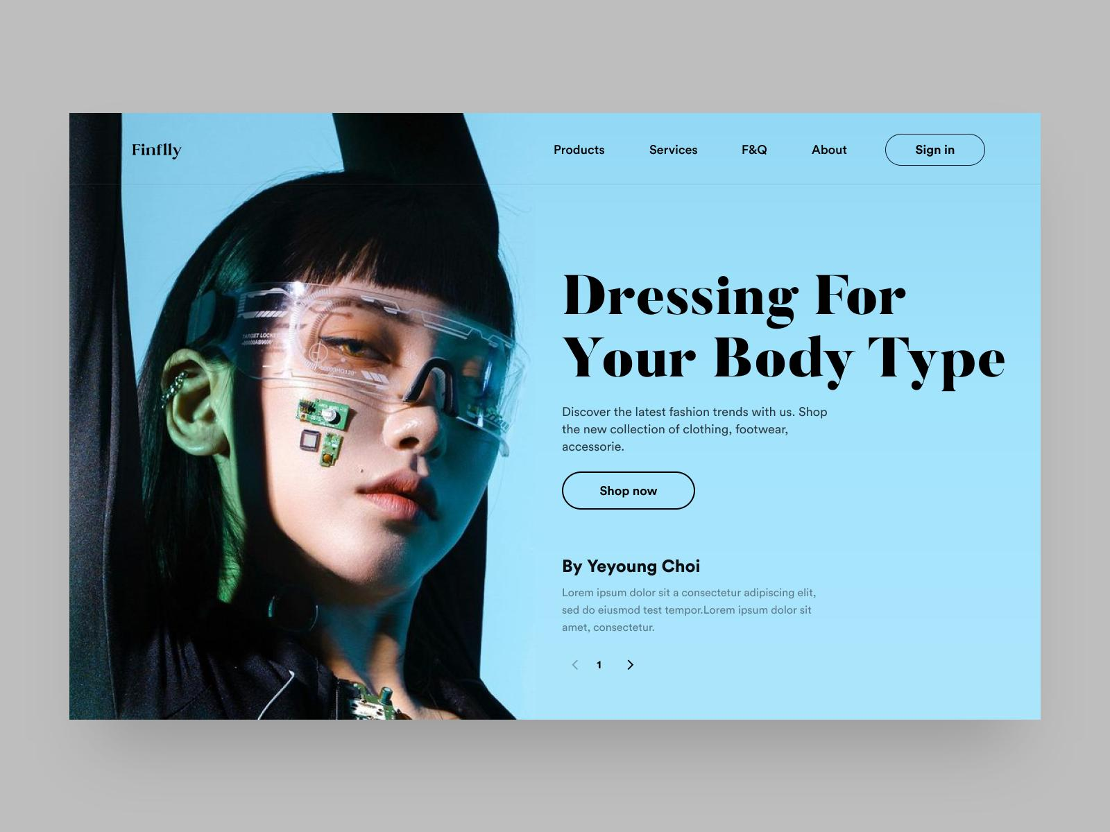
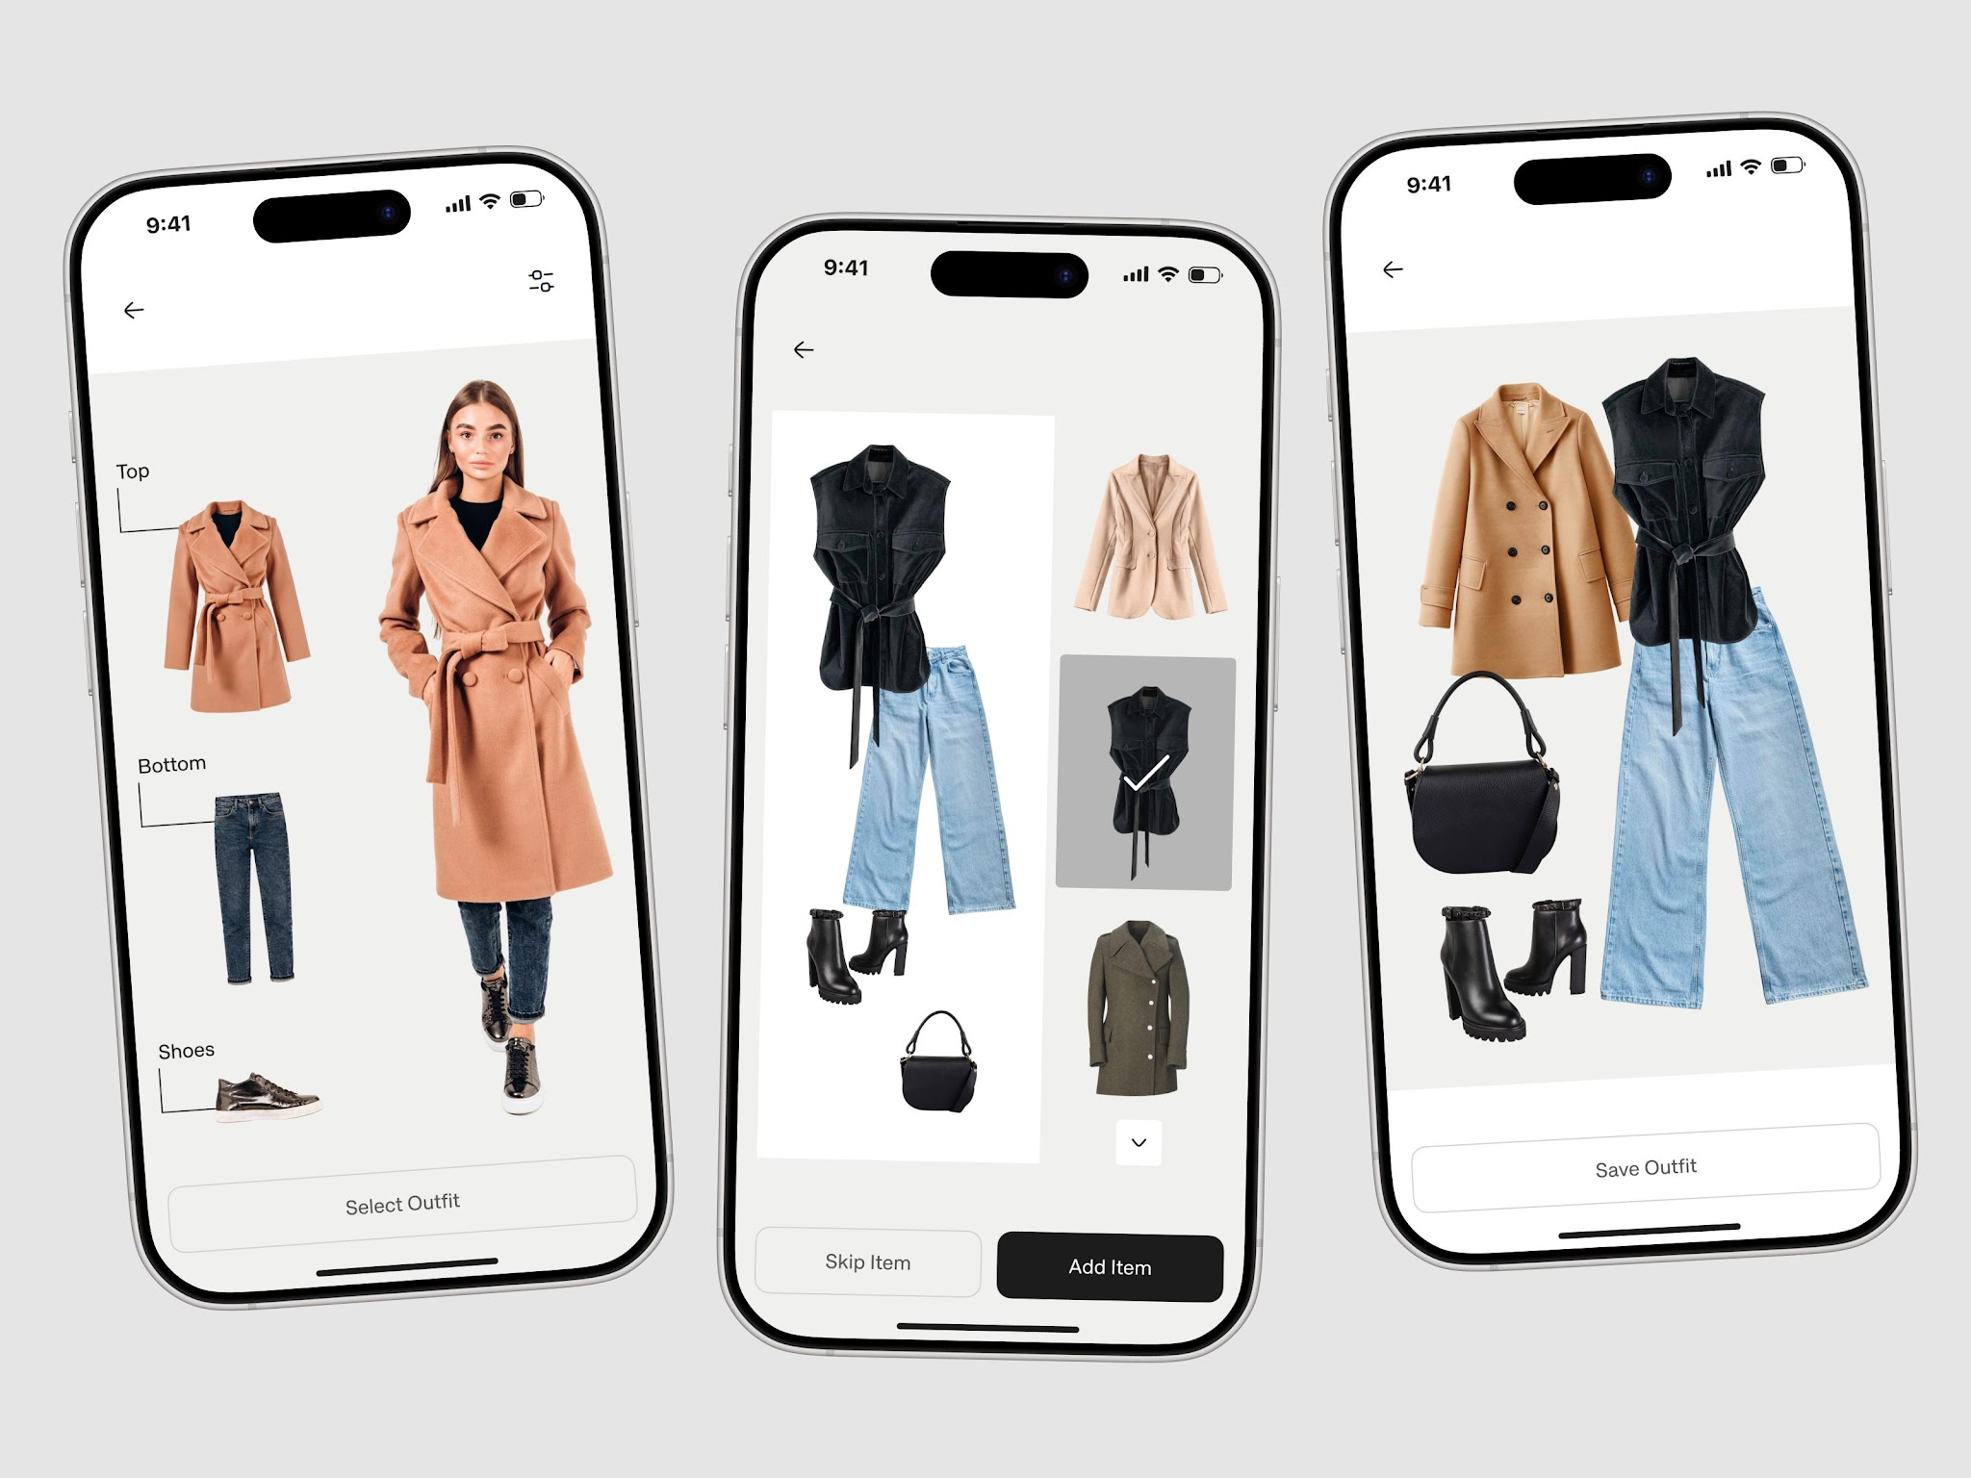
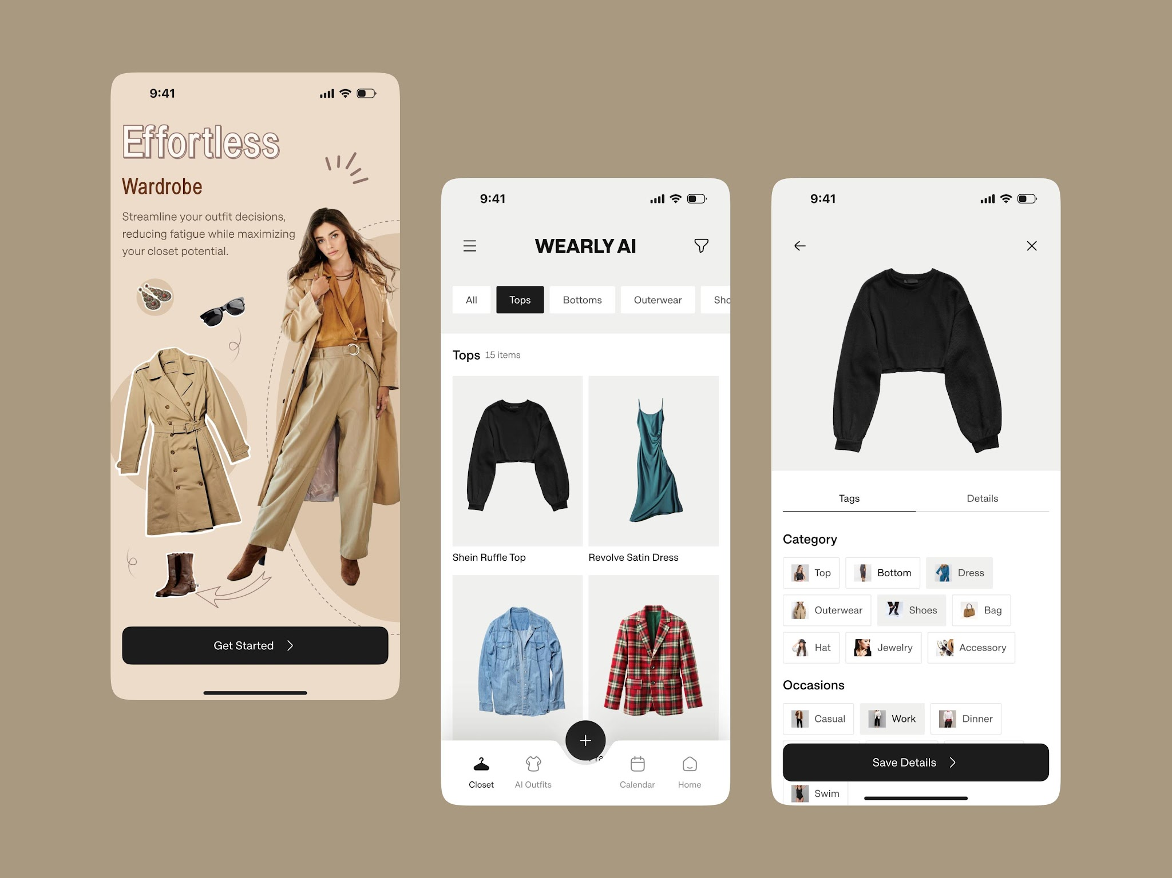
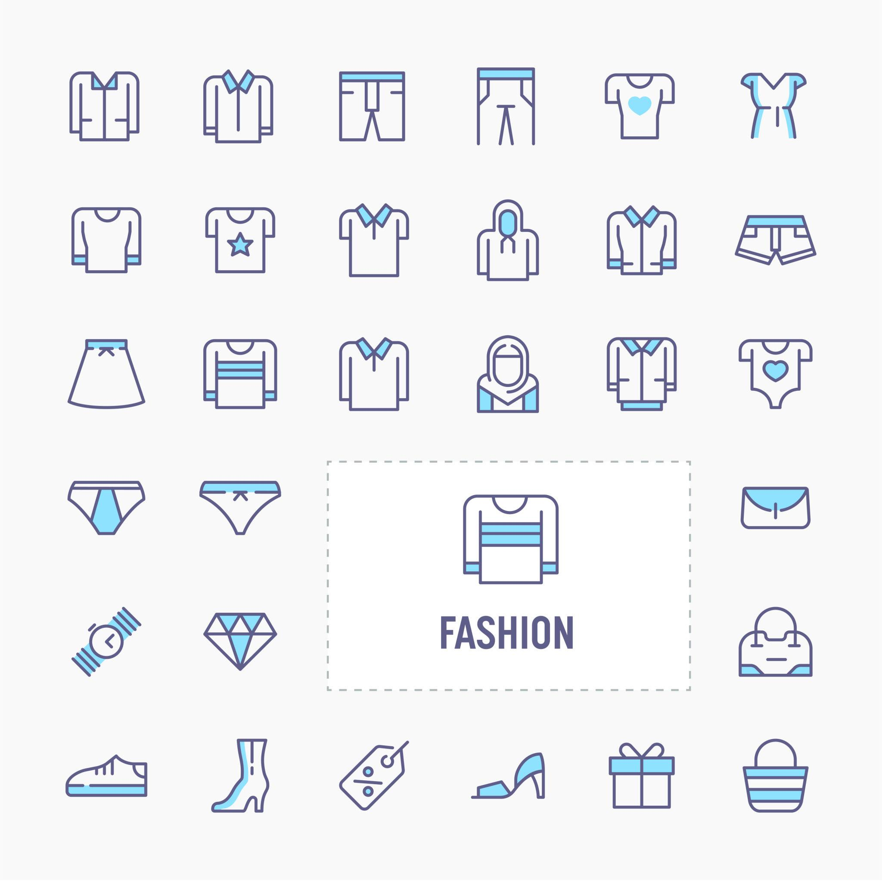
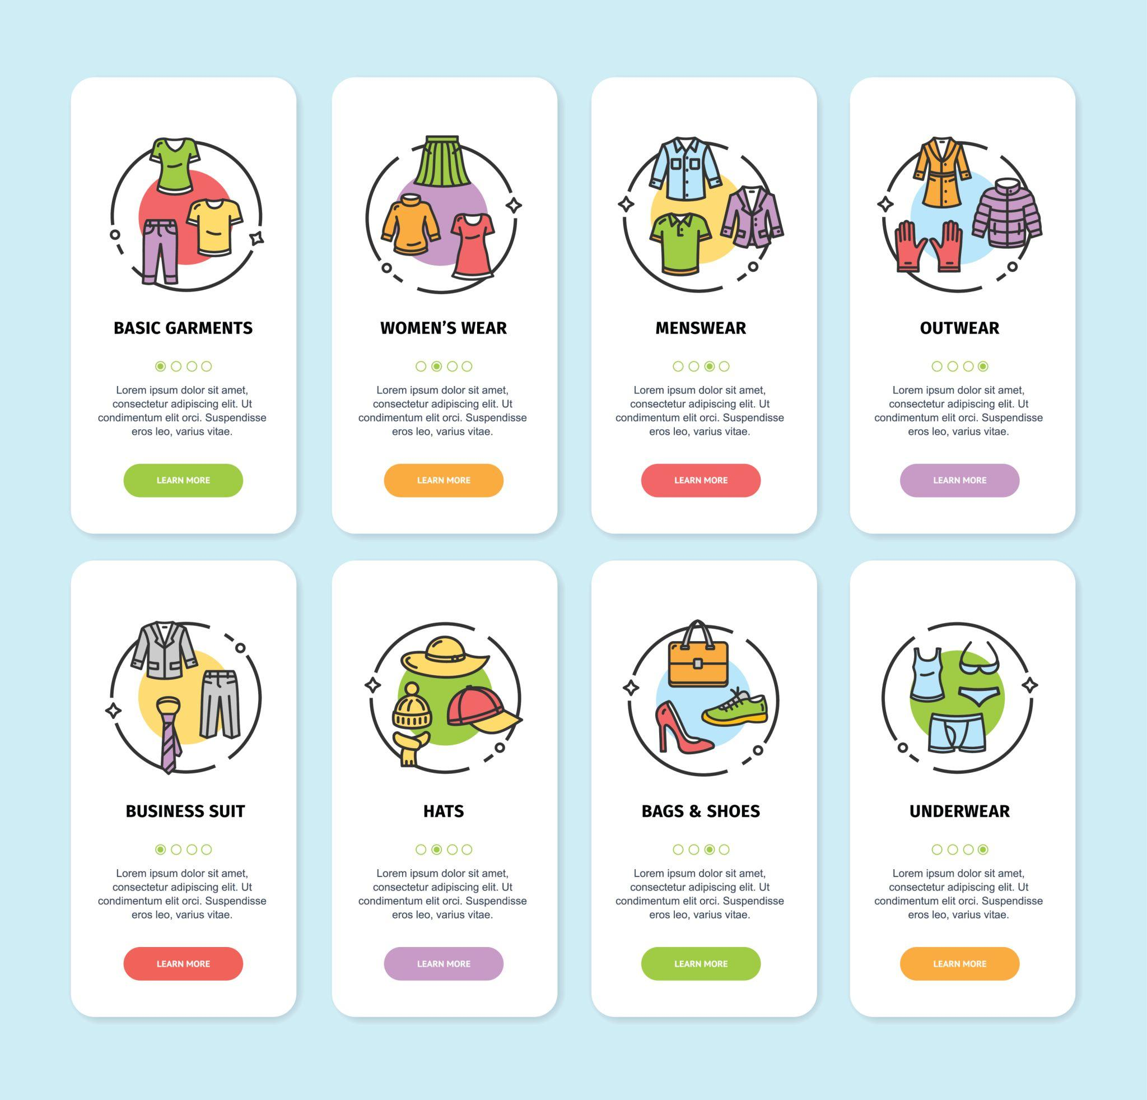
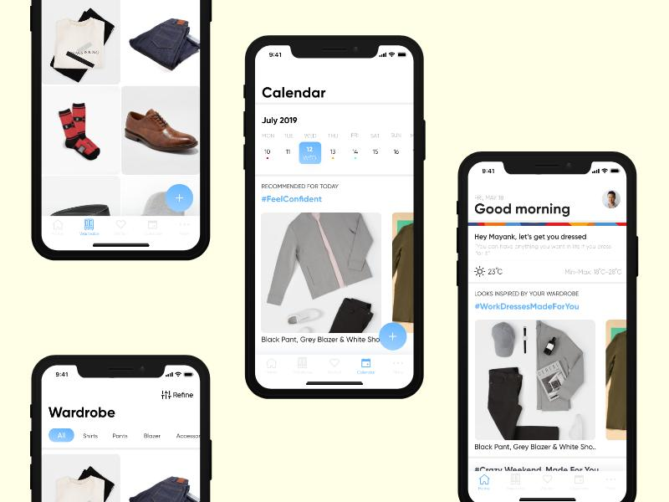
This is your main entry point.

User flow:
- Select outfit:
  - Saree
  - T-shirt
  - Bodycon dress
  - Office wear
  - Gym wear
- Select situation:
  - Office
  - Wedding
  - Casual outing
- Output:
  - Recommended undergarments
  - Why it works
  - What to avoid
  - Suggested products (affiliate)
👉 This = high conversion (money)

🧍 2. “Know your body” (Trust Builder)
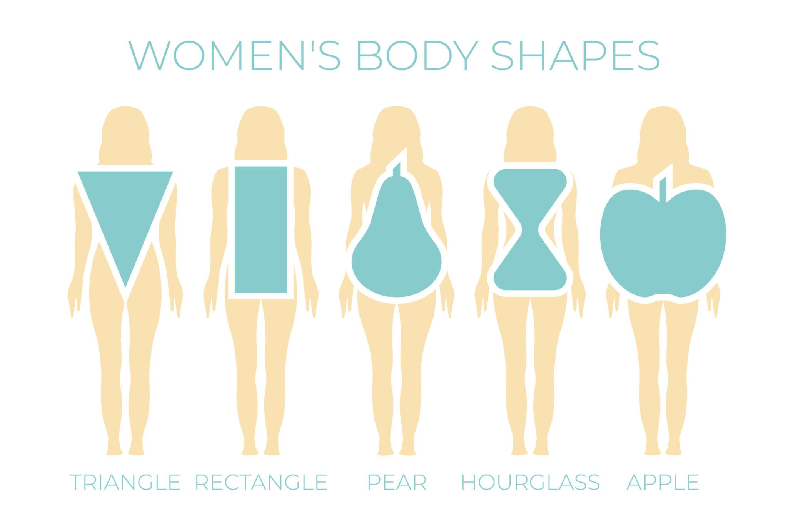
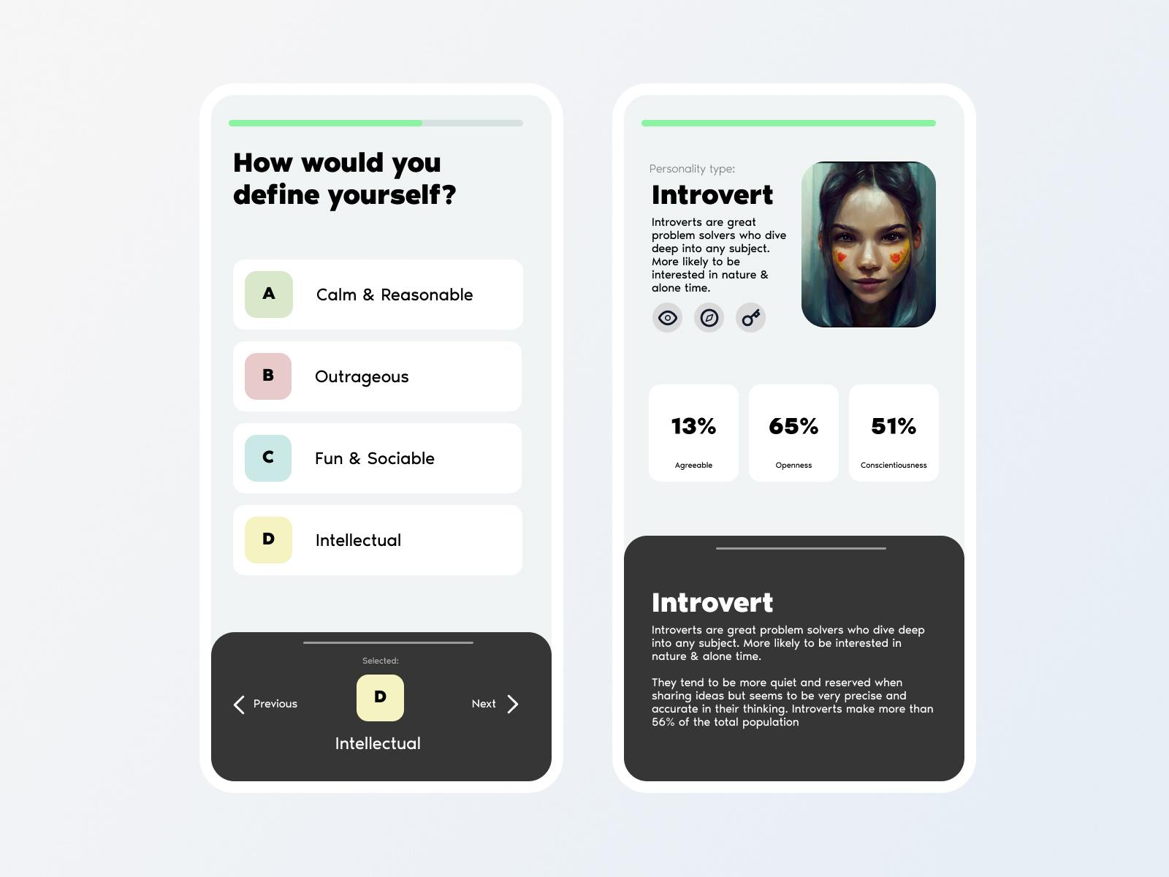
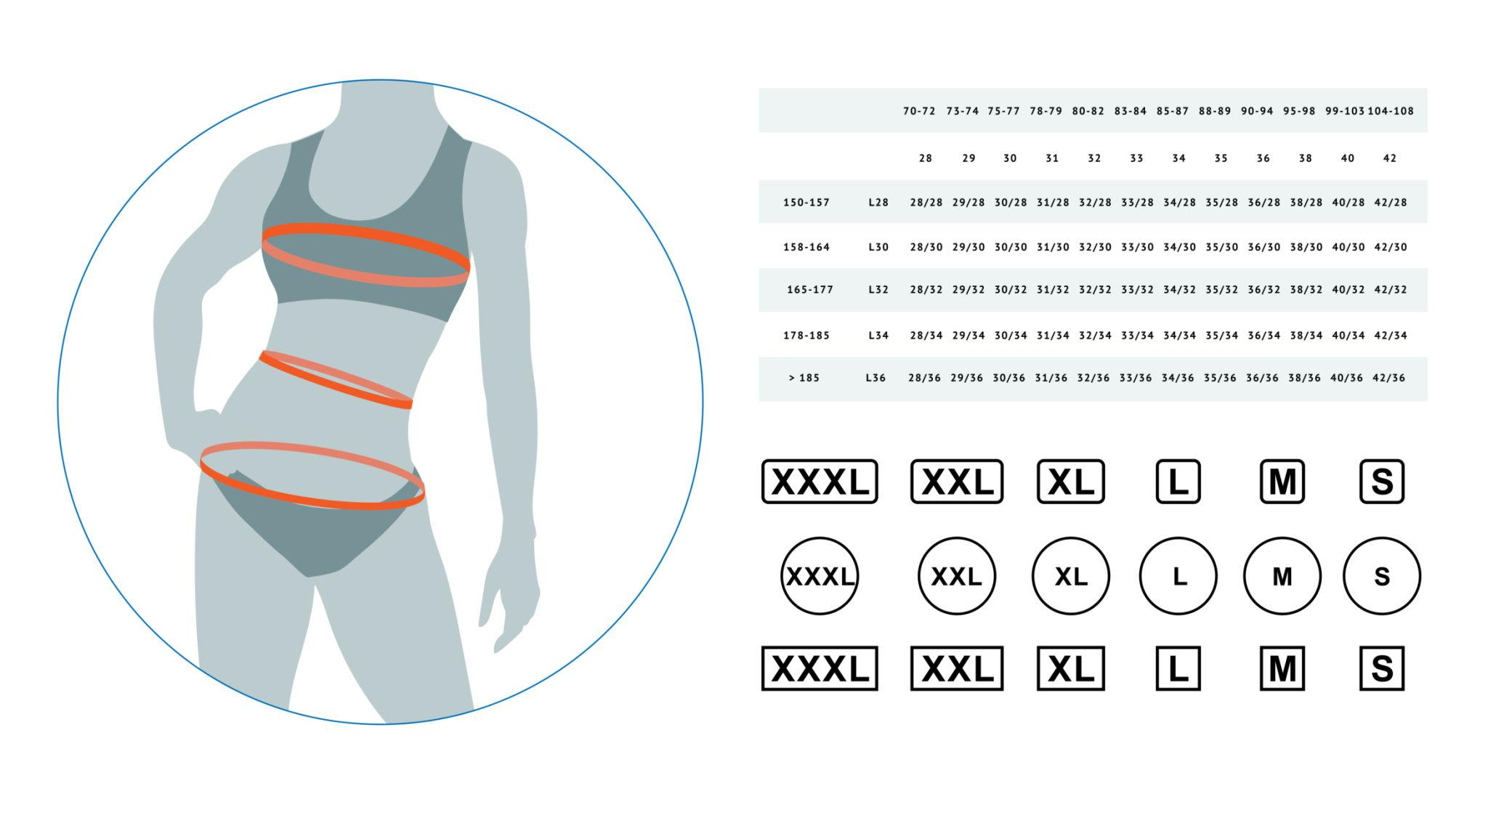
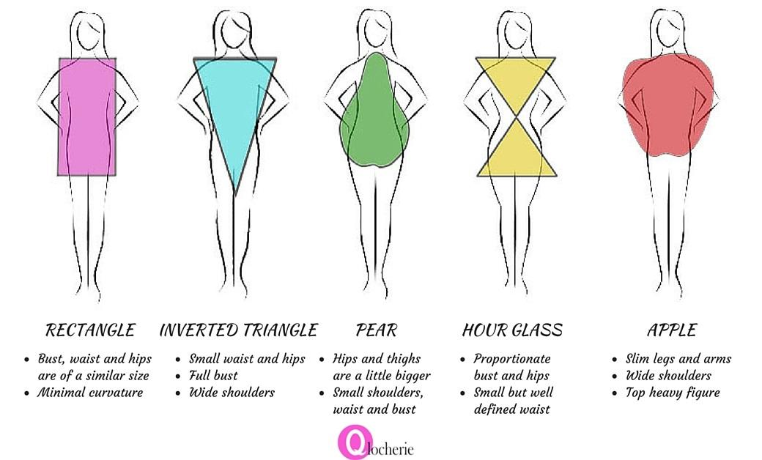
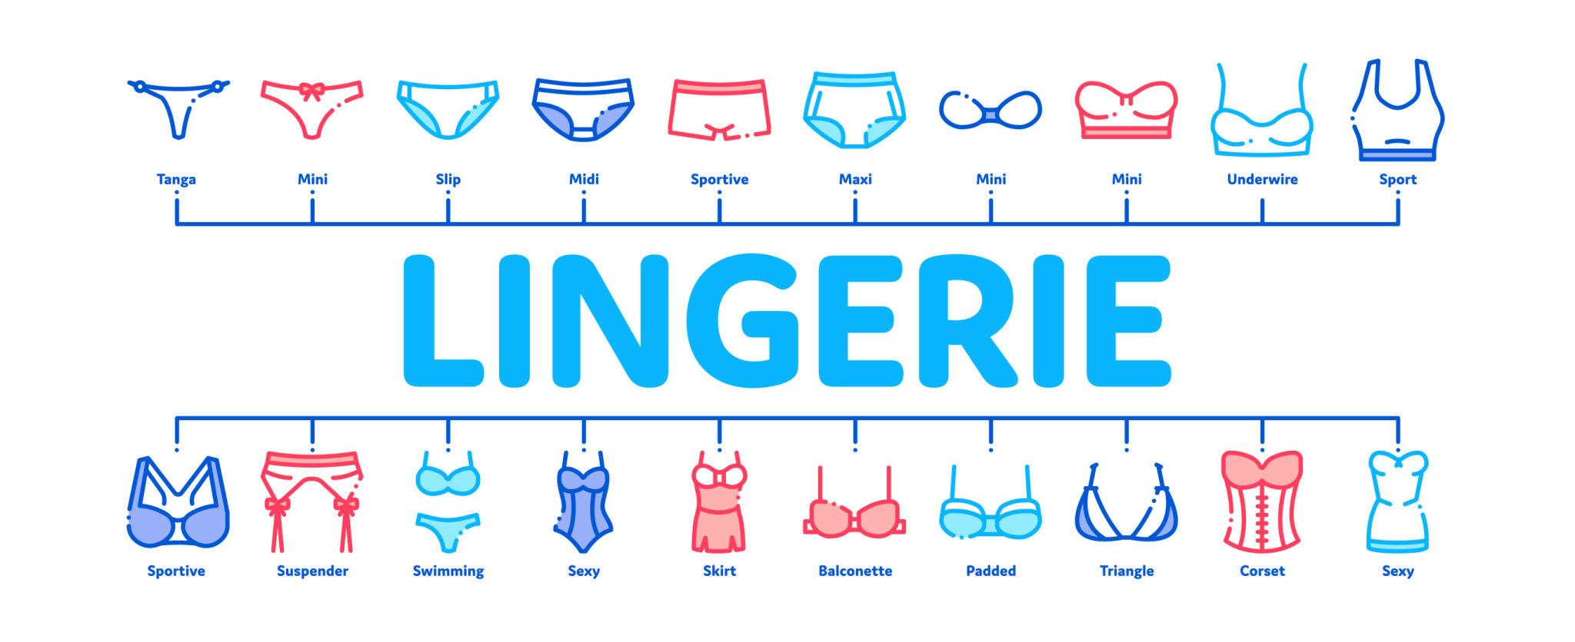
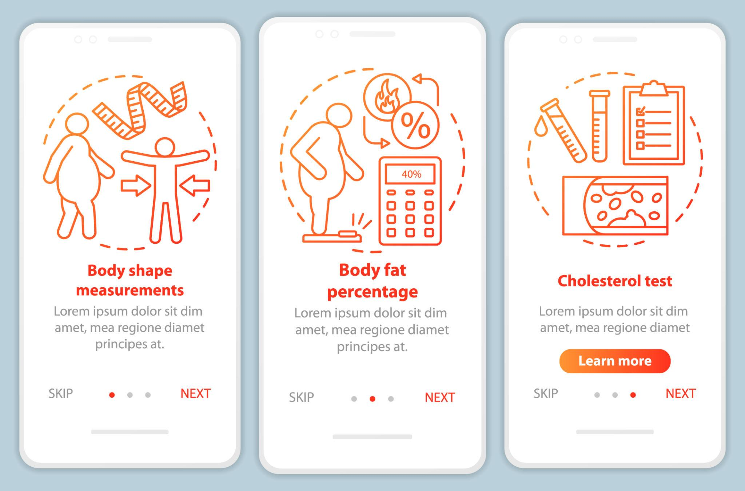
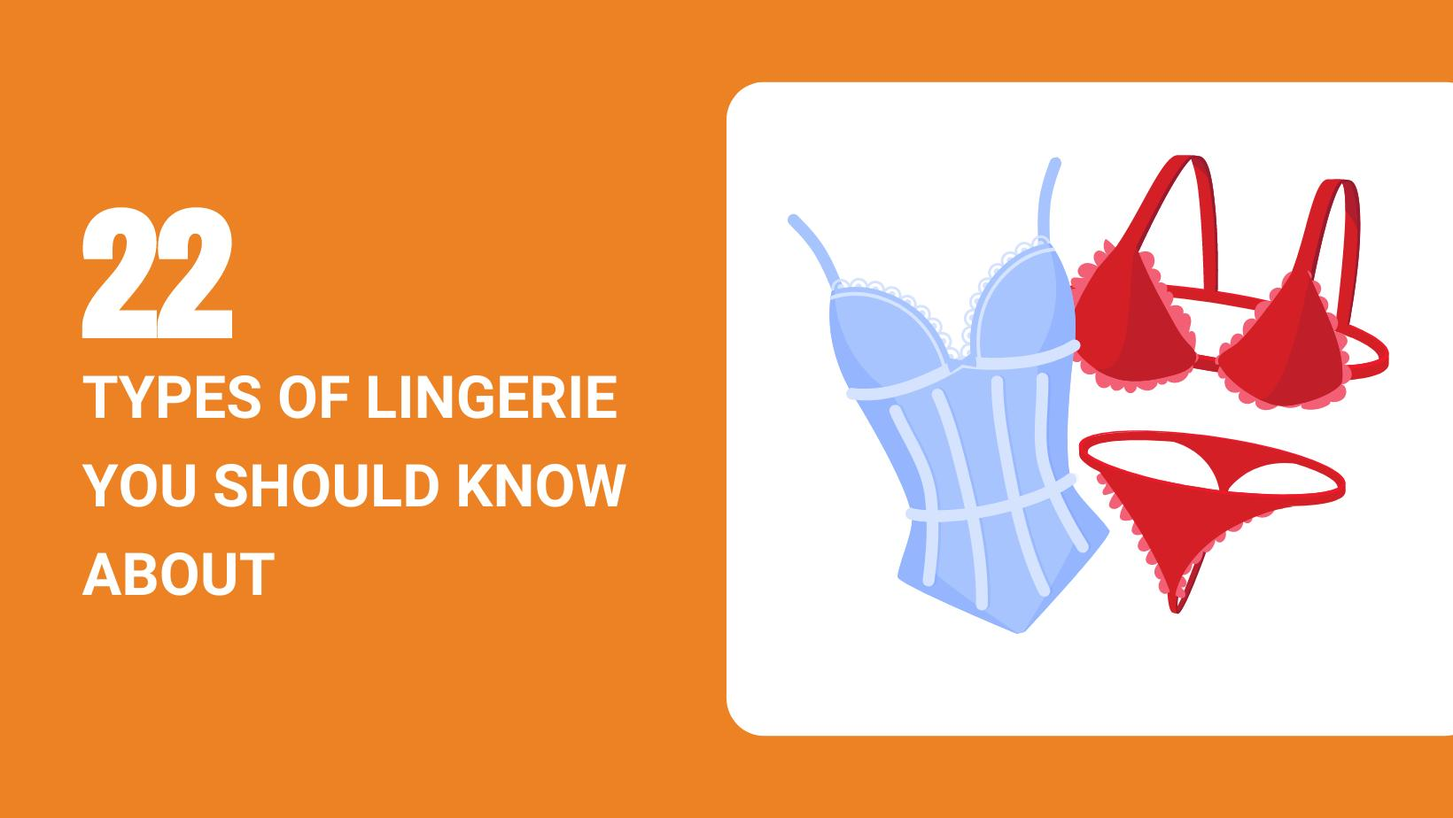
This is your engagement + education layer

Flow:
- Simple quiz:
  - shoulder width
  - waist
  - hips
→ Output:
- body type (pear, apple, etc.)
- what suits
- what to avoid
Then:
👉 connect to undergarments
👉 then to products

🧵 3. “Learn the basics” (SEO engine)
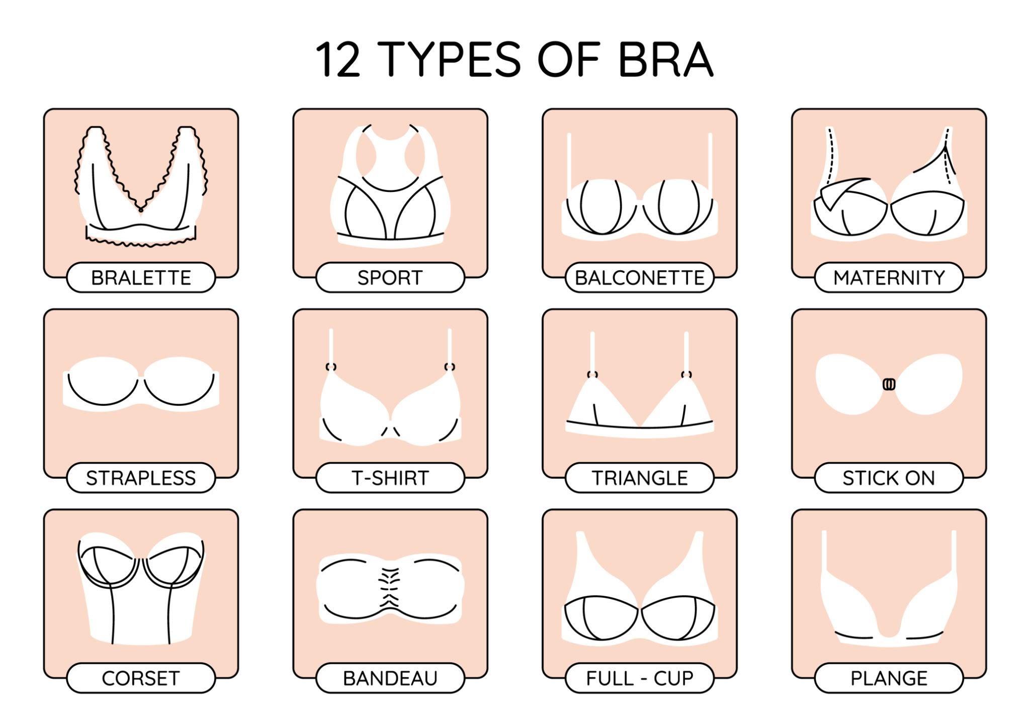
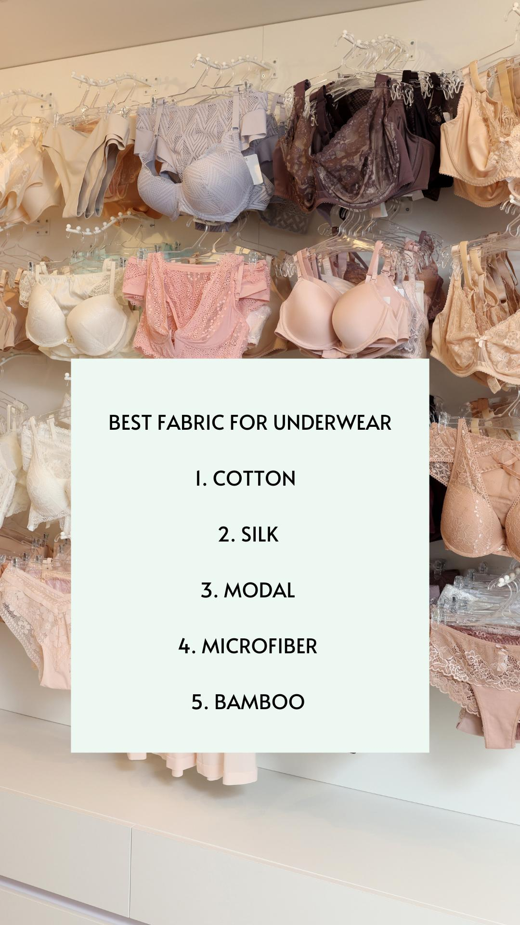
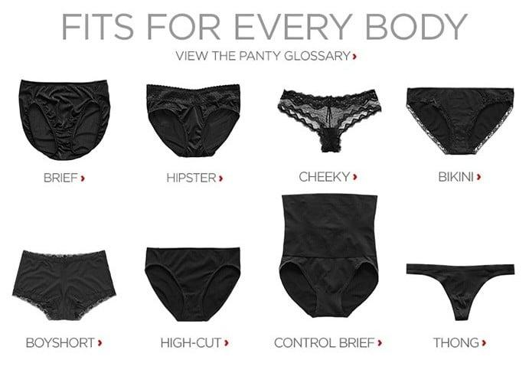
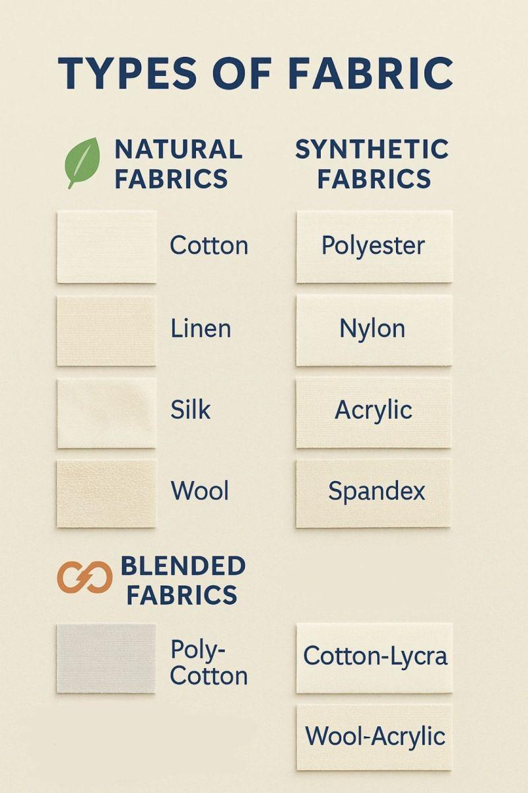
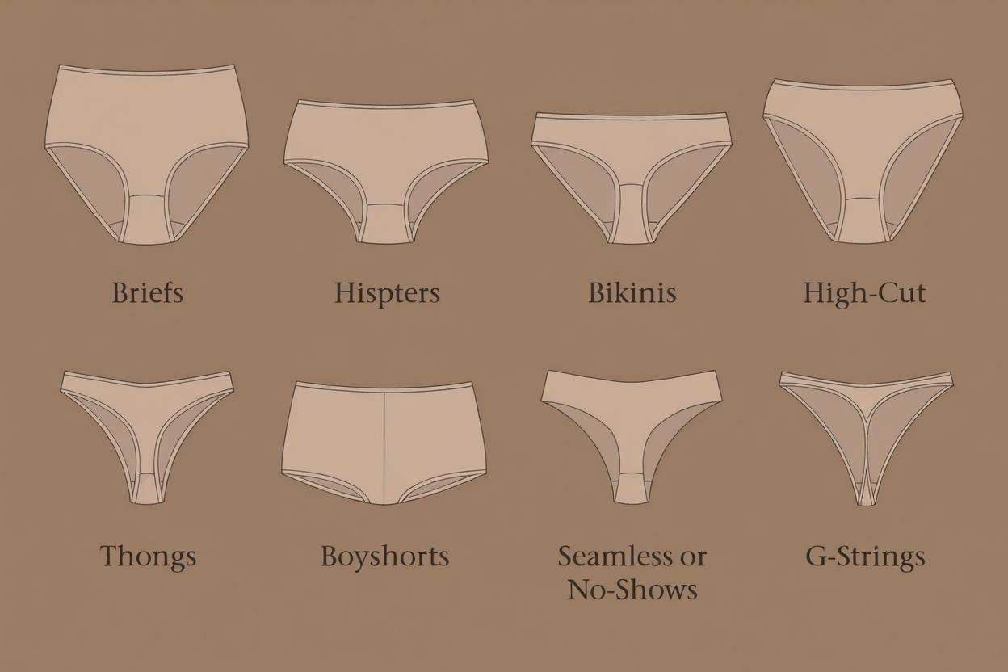
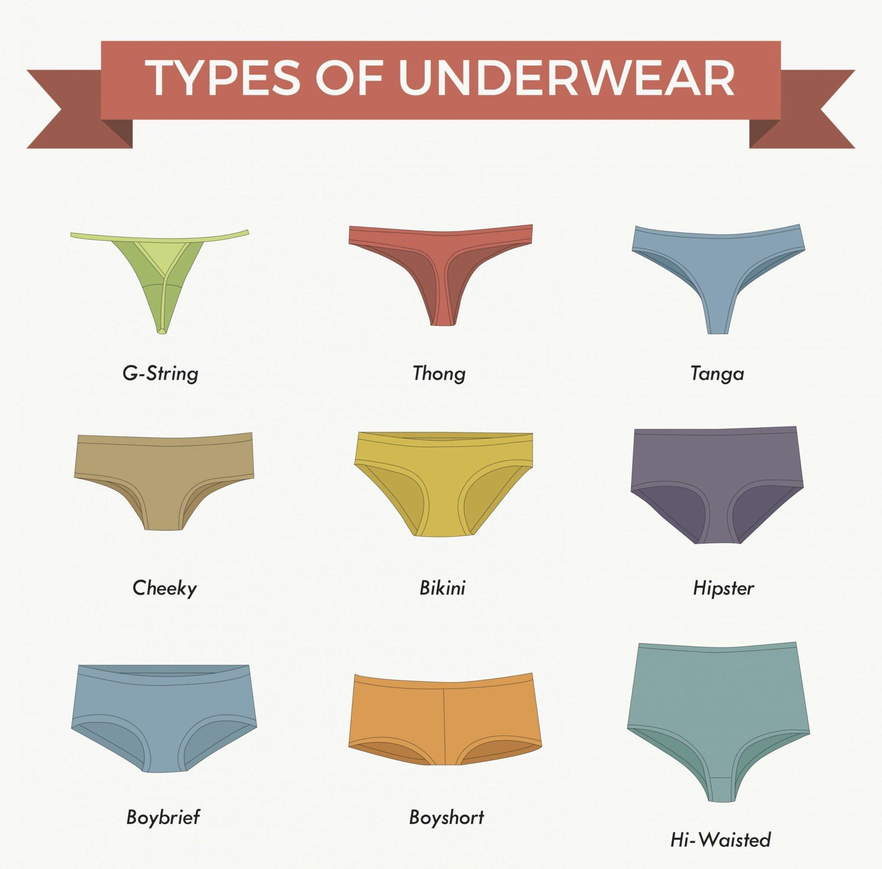
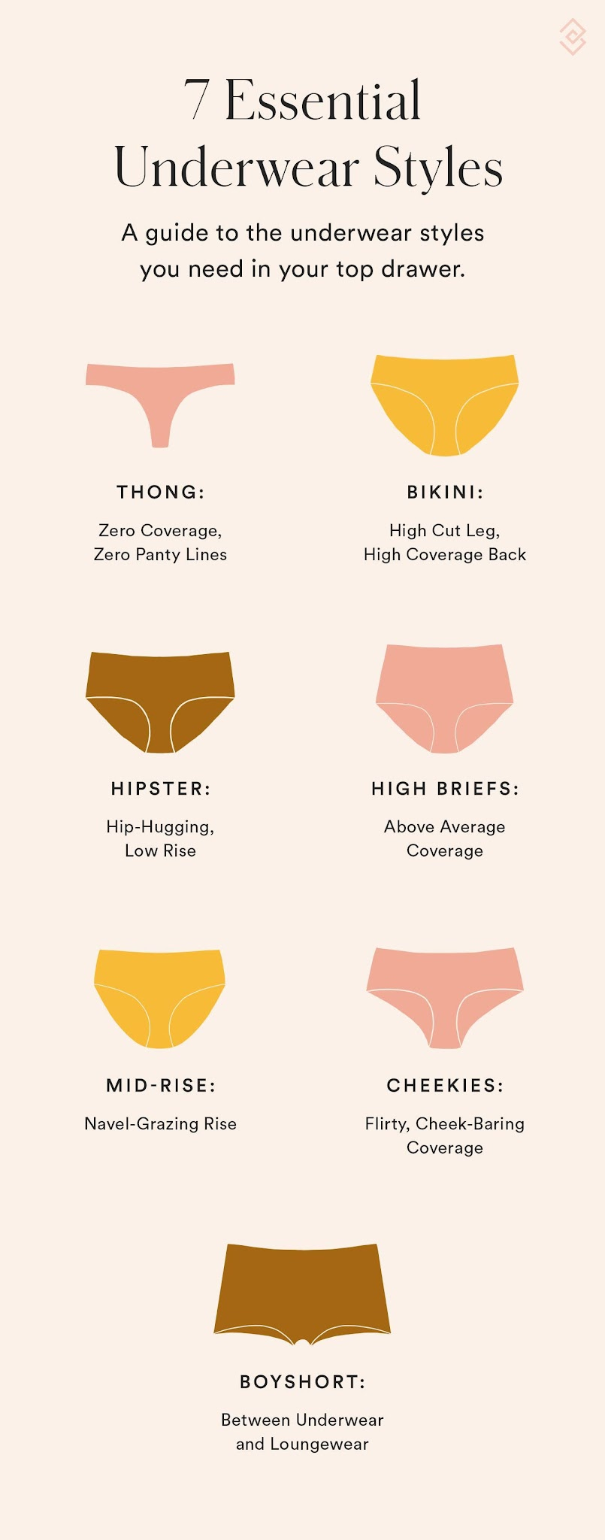
This is where Google traffic comes.
Content like:
- types of bras
- fabric guide
- seamless vs padded
- strap types
👉 This builds long-term traffic

🧩 Your 5 Ideas → Refined
You said:
- Dress → undergarments → fashion → links
- Body type
- Materials
- What to wear / not wear
- Why it matters
👉 All correct — but we group them like this:
Your Idea | Where it fits
Dress flow | Primary Flow
Body type | Trust Builder
Materials | Learn
Do/Don’t | Inside all flows
Why wear | Explanation layer

🎮 Gamification (make it special)
You mentioned gamification — good instinct.
But don’t overcomplicate.

Keep it simple:

Option A: Step-based flow
- Step 1 → Choose outfit
- Step 2 → Choose occasion
- Step 3 → Get result
👉 feels like a journey

Option B: Quiz style
- “Find your perfect innerwear in 30 seconds”
👉 very engaging

Option C: Score / Result
- “Comfort Score: 8/10”
- “Style Match: High”
👉 small touch, big impact

💰 Where Money Happens (Important)
Don’t push products everywhere.

Best placement:
After giving value:
“Based on your choice, here are 3 good options”
Buttons:
- View Product
- Compare
👉 clean, non-pushy

🎨 UI Direction (perfect for you)
Based on your previous work:
- mobile-first app style
- bottom navigation (Home / Explore / Learn / Profile)
- card-based UI
- rounded corners (like your Sky idea)

🧠 Critical Decision You Must Make
Before starting, answer this:

Who is your primary audience?

Option A:
Women (direct users)
→ safer, scalable

Option B:
Men (buying for partner)
→ unique niche, less competition

Option C (Best):
Both
→ but tone must be neutral & respectful

⚠️ One Risk (be careful)
Don’t make it feel like:
- “hidden curiosity platform” ❌
Make it feel like:
- “practical, helpful, normal” ✅
That decides trust.

🚦 Final Direction (clear path)
Start like this:

Phase 1 (MVP)
- Outfit → recommendation flow
- 10–15 articles
- affiliate links

Phase 2
- body type quiz
- better UI
- more categories

Phase 3
- personalization
- collections
- brand collaborations

🔥 Final Thought
What you’re building is actually:
“A private but trusted assistant for something people don’t openly ask.”
That’s why it can work very well if done right.

If you want next step, I’ll:
- design your exact homepage layout (mobile UI structure)
- or create user flow wireframe (step-by-step screens)
- or help you name + brand identity
Just tell me 👍

did we named this app

Not yet — but now that the vision is clearer, we can name it properly.
Your app sits between:
- fashion guidance
- body confidence
- undergarment education
- outfit pairing
- private/self-guided discovery
So the name should feel:
- safe
- modern
- elegant
- non-creepy
- memorable
- scalable beyond only lingerie

🎯 Best Naming Directions for Your Idea

1. Soft & Premium (Recommended for trust)
These feel like modern fashion/wellness brands.

Names:
- Innerly
- Wearwise
- UnderTone
- Lynelle
- Veila
- InnerHue
- Layered
- Align Wear
- Fitveil
- The Inner Edit
👉 These are safest for long-term branding.

👗 2. Fashion Editorial Style
Feels like magazine + style guide.

Names:
- Style Beneath
- Inside the Outfit
- UnderForm
- The Base Layer
- Dress Within
- WearTheory
- Under Notes
- Layer Logic
👉 Very aligned with your educational direction.

🧠 3. Smart Recommendation / Quiz Style
Feels more app-like and interactive.

Names:
- FitMatch
- WearMap
- InnerMatch
- DressFlow
- FitPath
- StylePair
- LayerSync
👉 Good if gamification becomes central.

🌸 4. Feminine + Modern Brand Style
If targeting women more directly.

Names:
- Lunelle
- Veloura
- Elara Wear
- Aureline
- Sereva
- Nuvette
👉 Feels like D2C brand names.

🧩 My Strong Recommendation for YOUR idea
Based on your direction:
- educational
- classy
- decision guidance
- future scalability
These stand out most:

⭐ Top Picks

1. Wearwise
Simple, trustworthy, scalable.
Meaning:
smart choices in what to wear

2. Layer Logic
Very unique.
Meaning:
logic behind layers and styling

3. The Inner Edit
Feels premium and editorial.

4. Innerly
Minimal, modern app-style name.

5. WearTheory
Very strong if content-heavy.

🧠 One Branding Advice
Avoid names that sound:
- overly sensual
- adult-oriented
- lingerie-only
Because your real value is:
guidance + confidence + pairing
Not just products.

🎨 My Personal Pick for You

Layer Logic
Because your entire platform is literally:
- what layer suits what
- body + outfit logic
- educational + modern
- neutral for both men & women
And it sounds:
- smart
- scalable
- premium
- memorable

If you want, next I can:
- design a brand identity direction
- create a logo concept description
- or help check domain availability style ideas for shortlisted names.

lock Innerly, generate first dashboard image.

We’re so sorry, but the image we created may violate our content policies. If you think we got it wrong, please retry or edit your prompt.
did we discussed about what tech or thing to impliment to achive diffrent types of calculatar that not only give result it suggests and many more. then rest asusal iso standerd code architure pages folderstructure and components.

Yes — and now your “Innerly” concept actually has a very clear technical direction.
You are not building a normal website anymore.
You are building:
A recommendation engine + educational fashion system
So your calculators are not “math calculators.”
They are:
- decision engines
- guided recommendation systems
- rule-based AI flows

🧠 Core Architecture You Need
Your app has 3 intelligence layers:
Layer | Purpose
Static Knowledge | rules, categories, education
Recommendation Engine | suggests based on choices
Future AI Layer | conversational/personalized guidance

🚀 BEST TECH STACK FOR YOU
Based on:
- your current skill level
- your previous app building
- scalability
- mobile-first UI
This is the best path:

🧩 FRONTEND

⚡ Next.js (Recommended)
Using:
- App Router
- TypeScript
- Tailwind
- ShadCN UI
Why:
- SEO friendly (VERY important for your content traffic)
- app-like feel
- scalable architecture
- fast loading
- easy deployment

🎨 UI SYSTEM

Tailwind + ShadCN
Perfect for:
- premium fashion UI
- reusable components
- clean design system
You already think in:
- cards
- sections
- mobile-first
This stack fits you perfectly.

🧠 RECOMMENDATION ENGINE (MOST IMPORTANT)
This is what you were asking about.
You do NOT need complex AI initially.

✅ PHASE 1 — Rule-Based Recommendation Engine
This is enough to make the app intelligent.
Example logic:
IF:
dress = "bodycon"
AND event = "party"

THEN:
recommend = seamless shapewear
avoid = visible straps
Another:
IF:
bodyType = "pear"

THEN:
recommend = high waist styles

🧩 How to Build This Properly

Use JSON Knowledge System
Example:
{
"dressType": "saree",
"occasion": "wedding",
"recommended": [
"strapless bra",
"shapewear"
],
"avoid": [
"visible straps"
]
}

🔥 Why This Is Powerful
Because:
- easy to maintain
- easy to scale
- no AI cost initially
- fast responses
- can later evolve into AI

🧠 FUTURE PHASE — AI Layer
Later you can add:

AI Assistant
Example:
“I’m wearing white shirt for office. What innerwear suits?”
AI converts:
- shirt
- office
- fabric
- comfort
→ into recommendations.

🤖 WHAT AI TO USE LATER
For future:
- OpenAI API
- Gemini API
- Local embeddings
But NOT needed now.

🗂️ PERFECT PROJECT STRUCTURE
Since you mentioned ISO-style architecture:
Here’s the right setup.

📁 Suggested Folder Structure
src/
│
├── app/
│ ├── (public)
│ ├── dashboard
│ ├── explore
│ ├── learn
│ ├── quiz
│ └── api
│
├── components/
│ ├── ui
│ ├── cards
│ ├── recommendation
│ ├── quiz
│ └── layout
│
├── features/
│ ├── body-shape
│ ├── outfit-match
│ ├── fabric-guide
│ └── recommendations
│
├── data/
│ ├── garments.json
│ ├── bodytypes.json
│ ├── occasions.json
│ └── rules.json
│
├── services/
│ ├── recommendation-engine.ts
│ ├── scoring.ts
│ └── analytics.ts
│
├── hooks/
├── lib/
├── utils/
└── types/

🧠 Your “Calculators” Are Actually These:

1. Outfit Matcher
Input:
- dress
- event
Output:
- undergarment recommendation

2. Body Shape Analyzer
Input:
- measurements
- shape selection
Output:
- best styles

3. Fabric Compatibility Engine
Input:
- outerwear material
Output:
- suitable innerwear fabric

4. Comfort Score Engine
Example:
- breathable
- sweat control
- movement comfort

🎮 Gamification Layer
Very easy later.
Example:
- style score
- comfort meter
- confidence score

🧱 DATABASE

Start Simple
Use:
- Supabase
Why:
- auth
- database
- storage
- scalable
- beginner friendly

🚀 Hosting

Vercel
Perfect for:
- Next.js
- SEO
- scaling

🔍 SEO (MOST IMPORTANT FOR INCOME)
Your site growth depends heavily on search traffic.
So:
- article pages
- structured metadata
- schema markup
- clean URLs
are critical.

🎯 BEST DEVELOPMENT STRATEGY

Phase 1 (MVP)
Build:
- homepage
- outfit matcher
- 20 content pages
- affiliate system
NO AI yet.

Phase 2
Add:
- quizzes
- recommendation engine
- personalization

Phase 3
Add:
- AI assistant
- saved profiles
- wardrobe memory

🧠 Final Important Insight
You are NOT making:
“fashion content website”
You are making:
“decision support system for personal wear.”
That mindset changes:
- architecture
- UX
- monetization
- scalability
completely.

And yes:
Your instinct about:
- architecture
- reusable systems
- intelligent calculators
- modular design
…is exactly the correct direction for this project.

https://ecommerce-codex-demo.vercel.app/clothes
will use this website colors and style. i liked it

That style direction is actually a very smart choice for Innerly.
The site you shared has:
- soft luxury colors
- editorial fashion feel
- minimal layout
- premium spacing
- app-like shopping flow
- modern typography
- calm UI
That fits your vision perfectly.

🎨 What You’re Actually Choosing
You are choosing a:
“premium feminine editorial interface”
instead of:
- e-commerce clutter ❌
- aggressive pink lingerie style ❌
- spam fashion UI ❌
This is GOOD.

🧠 Why This Style Fits Innerly
Your app is:
- educational
- recommendation-driven
- private/personal
- fashion-aware
So users need to feel:
- calm
- safe
- premium
- guided
This aesthetic supports that psychologically.

🎯 What to Reuse from That Design

1. Color Palette
Soft:
- beige
- cream
- muted brown
- warm white
- dusty tones
Perfect for:
- trust
- elegance
- body/fashion themes

2. Card Style
Rounded large cards:
- excellent for outfit selection
- quiz flow
- recommendations

3. Typography
Fashion-editorial typography gives:
- magazine feeling
- premium brand vibe

4. White Space
VERY important for your niche.
Too much content density:
→ feels cheap or awkward
Spacious layout:
→ feels trustworthy

🚀 PERFECT UI DIRECTION FOR INNERLY
Now your UI vision becomes:
Layer | Style
Landing | editorial fashion
Recommendation Flow | app-like cards
Learn Pages | clean magazine
Affiliate Product Area | subtle premium storefront
Quiz | smooth guided onboarding

🧩 How Innerly Should DIFFER From That Template
This is critical.
That site is:
product-first
Innerly should be:
guidance-first
Meaning:

Their flow:
Product → Buy

Your flow:
Problem → Guidance → Confidence → Product
That’s your uniqueness.

🧠 Suggested Homepage Structure
Using that aesthetic:

HERO SECTION
Large soft image:
- layered fashion look
- elegant composition
Text:
“Know what works beneath every outfit.”
CTA:
- Explore Styles
- Find Your Match

INTERACTIVE ENTRY CARDS
Like:
- 👗 Choose Your Outfit
- 🧍 Find Your Body Shape
- 🧵 Fabric Guide
- 🎯 Event Styling

OUTFIT MATCHER
Cards:
- Saree
- Office Wear
- Gym Wear
- Party Dress
- White Shirt

EDUCATIONAL GRID
Minimal cards:
- Strap Guide
- Seamless vs Padded
- Everyday Comfort
- What Not to Wear

AFFILIATE SECTION
NOT “SHOP NOW”
Instead:
“Recommended Picks”
Subtle.

🧱 TECH DIRECTION NOW BECOMES CLEAR
You now have:

FRONTEND STYLE
Next.js + Tailwind + ShadCN
(Perfect for this aesthetic)

ANIMATION
Use:
- Framer Motion
- subtle fade
- soft transitions
NOT:
- flashy ecommerce motion

IMAGE STYLE
Use:
- editorial crop
- muted grading
- soft lighting

🧠 VERY IMPORTANT PRODUCT DECISION
You should NOT call products:
- “Sexy”
- “Hot”
- “Bold”
Instead:
- Comfortable
- Minimal
- Supportive
- Everyday
- Occasion-ready
This changes the entire brand perception.

🔥 Innerly’s REAL Identity
Not:
lingerie platform
But:
“wear intelligence platform”
That’s the positioning.

🧭 Final Strategic Advice
Before coding:

Build these FIRST in Figma:
- Homepage
- Outfit flow
- Recommendation card
- Quiz flow
- Learn page
Only after that:
→ start development.

And yes — this design direction is genuinely aligned with your vision. It gives Innerly:
- legitimacy
- elegance
- scalability
- trust
without feeling awkward or commercial-heavy.
Quick recap.
Example
Know your body type
Rectangle
Square
Triangle
Pear

Then occasions
Home wear
Party
Events
Travel
Office

Based on this
Dress style names
Shudidar
Saree
Top and jeans.

Later affiliate ads not forced.

Similarly
For Brest and brass
Hip and panties

It's been a long time of recaping actually flow am i right

Yes, and after all the discussion, I think we're finally arriving at the actual product, not just the website.
Your flow is close, but I would change the order slightly.
Right now you're thinking:
Body Type → Occasion → Dress → Undergarment → Affiliate
But users don't naturally think that way.
Most people think:
"I'm wearing this outfit tomorrow. What should I wear underneath?"
So the flow should start from the problem they're trying to solve.

Innerly Core Flow

Path 1: Outfit First (Main Flow)

Step 1
What are you wearing?
- Saree
- Chudidar
- Kurti
- Top & Jeans
- Formal Shirt
- Party Dress
- Gym Wear
- Travel Wear

Step 2
Where are you going?
- Home
- Office
- College
- Wedding
- Party
- Travel
- Gym

Step 3
Tell us about yourself (Optional)
- Body Shape
- Height
- Comfort Preference
- Coverage Preference

Result
Innerly suggests:

Recommended Innerwear
- Type
- Why it works
- Comfort level

Things to Avoid
- Visible lines
- Strap issues
- Fabric mismatch

Related Fashion Tips

Recommended Products
(Affiliate)

Path 2: Know Your Body
For people who don't know their body type.

Quiz
- Rectangle
- Pear
- Apple
- Hourglass
- Triangle
- Inverted Triangle
Result:
- Body explanation
- Recommended fits
- Recommended innerwear
- Recommended clothing styles
This builds trust.

Path 3: Learn
This is your SEO engine.
Topics:

Breast & Bras
- Types of bras
- Push-up
- T-shirt bra
- Strapless
- Sports bra
- Nursing bra

Hips & Panties
- Bikini
- Hipster
- Boyshorts
- Briefs
- Seamless

Fabrics
- Cotton
- Modal
- Satin
- Lace
- Microfiber

Awareness
- What to wear under white clothes
- What to wear under sarees
- Common mistakes
- Comfort vs style

What I Think Is Missing
The strongest feature.

"Why?"
Every recommendation should answer:

Why this recommendation?
Example:
For a white office shirt, a nude seamless bra is recommended because white bras can show through lighter fabrics.
This is where Innerly becomes different.
Most sites say:
Buy this.
Innerly says:
Here's why.

Homepage Structure
Using the ecommerce-codex visual style:

Hero
"Find what works beneath every outfit."
Buttons:
- Start Matching
- Learn Basics

Main Cards
👗 Outfit Matcher
🧍 Know Your Body Type
🧵 Fabric Guide
🎓 Learn Innerwear Basics

Trending Guides
"What to wear under a saree"
"Best options for office wear"
"Travel comfort essentials"

Recommended Picks
Very subtle affiliate section.
No hard selling.

Long-Term Vision
After listening to all your ideas, I don't think Innerly is a fashion website.
I think it's:
A personal wear intelligence platform.
Users come for:
- confidence
- comfort
- knowledge
Products are simply the outcome.
That's why I would prioritize:
- Outfit Matcher
- Body Type Quiz
- Learn Section
- Affiliate Products
in that order.
If you build those four pillars well, you'll already have a strong MVP that feels genuinely useful rather than another fashion catalog.

Yes you are correct. And we are not suggest any out fit we are purely focused on inner wear. Matching to the outer wear and body and when and where

Exactly. This is the correction that makes Innerly much stronger.
If you start suggesting:
- Saree designs
- Fashion trends
- Clothing shopping
then you're competing with:
- Myntra
- Ajio
- Pinterest
- Fashion blogs
That's a huge market with heavy competition.

Innerly's True Positioning
Not:
Fashion Discovery Platform
Not:
Clothing Shopping Platform
Not:
Style Recommendation App
Instead:
Inner Wear Intelligence Platform
or
The Missing Layer Between Body and Outfit

What Innerly DOES
User says:
"I'm wearing a white shirt to office."
Innerly answers:
- Recommended bra type
- Recommended color
- Recommended fabric
- Things to avoid
- Why

User says:
"I'm wearing a saree for a wedding."
Innerly answers:
- Best bra options
- Shapewear suggestions
- Blouse compatibility
- Comfort considerations

User says:
"I'm traveling for 10 hours."
Innerly answers:
- Comfort-first recommendations
- Breathable fabrics
- Sweat management
- Support level

The Formula
Every recommendation should be based on:

Body
- Breast shape
- Body shape
- Hip shape
- Size preferences

Outer Wear
- Saree
- Kurti
- White Shirt
- Gym Wear
- Party Dress

Occasion
- Home
- Office
- Travel
- Wedding
- Party
=

Innerly Recommendation

MVP Navigation
I would build only these 4 sections initially:

Home
Main entry point.

Match
The recommendation engine.
Questions:
- What are you wearing?
- Where are you going?
- Tell us about yourself (optional)
Result.

Learn
Knowledge hub.
Categories:

Bras
- Types
- Usage
- Fit

Panties
- Types
- Usage
- Fit

Fabrics
- Cotton
- Modal
- Lace
- Seamless

Guides
- Do's and Don'ts
- Common Mistakes

Body Guide
Quiz and educational section.

Affiliate Placement
This is where many people make mistakes.
Don't do:
Recommendation → BUY NOW BUY NOW BUY NOW
Do:

Recommendation
Why this works.

Suggested Options
3–5 products.
That's it.
No pressure.

What Makes Innerly Unique
Most websites answer:
"What product should I buy?"
Innerly answers:
"What should I wear underneath this outfit, and why?"
That "why" becomes your moat.

One More Feature I Would Add

Confidence Check
Example:
User selects:
- White shirt
- Office
Innerly displays:
Visibility Risk: Low ✅
Comfort Score: High ✅
Support Level: Medium ✅
Travel Friendly: Yes ✅
This is simple logic, but it feels intelligent and gives users confidence in the recommendation.

At this point, your MVP is becoming very clear:
Innerly = Body + Outfit + Occasion → Right Innerwear + Explanation + Optional Product Recommendations
That is focused, understandable, and much easier to build than a full fashion platform.
That is a nice feature to have.
When user lands we have flow as above. Later explored and referred. The user should be able to go directly to know things like which type of bra suited based on they body and brest. Similar to panties this like reverse engineering to the home page flow.
I am a male user. I want gift may girlfriend no need to ask her about things. I know few things about her. Hence i come here answer what I know and gain what should I buy. Buying from here or some wear is user choice but he should educated with right knowledge

Now we're getting to the interesting part.
What you've just described is not one user journey. It's actually three different user personas, and Innerly becomes much more valuable when it supports all three.

Persona 1: The Wearer (Primary User)
This is the most common user.
Example:
"I'm wearing a saree to a wedding."
Flow:
Outfit → Occasion → Body Details (optional) → Recommendation
This is the flow we've been discussing.

Persona 2: The Learner (Knowledge User)
Example:
"What is a balconette bra?"
"What is a hipster panty?"
"What's the difference between cotton and modal?"
This user doesn't need recommendations.
They want:
Learn → Category → Article → Related Recommendations
This is your SEO engine.

Persona 3: The Gifter (Your Unique Opportunity)
This is the one that made me stop and think.
Because most competitors don't serve this audience well.
Example:
"I want to buy something for my girlfriend."
"I know she usually wears kurtis."
"She prefers comfort."
"She's petite."
"I don't know bra terminology."
This is where Innerly becomes genuinely useful.

Gift Finder Flow
Instead of asking:
"What bra size is she?"
(which many men won't know)
Ask:

What do you know?
- Approximate body type
- Clothing style
- Occasion
- Comfort vs fashion
- Age range
Then educate:
Based on what you've told us, these categories may suit her.
Then explain:
A T-shirt bra is often preferred because...
A seamless style helps because...
Then optionally show products.

This Changes the Homepage
Initially we thought:

Hero
Find what works beneath every outfit.

Now I would do:

Hero
Find the right innerwear for your body, outfit, and occasion.

Then show 3 entry cards:

👗 Match My Outfit
For wearers.

📚 Learn the Basics
For knowledge seekers.

🎁 Find a Gift
For partners.
This immediately broadens your audience.

Reverse Engineering Is Correct
You said:
user should be able to go directly to know which type of bra suits their body and breast
Exactly.
Think of Innerly as a knowledge graph.
Users can enter from any direction:

Entry Point A
Outfit → Recommendation

Entry Point B
Body Type → Recommendation

Entry Point C
Bra Type → Learn Usage

Entry Point D
Panty Type → Learn Usage

Entry Point E
Gift Finder → Recommendation

All roads eventually connect.

Your Real Information Model
This is what your database will eventually look like:

Body
- Rectangle
- Pear
- Apple
- Hourglass
↓

Breast
- Shape
- Support Need
- Coverage Need
↓

Hip
- Shape
- Coverage Preference
↓

Occasion
- Office
- Travel
- Wedding
- Home
↓

Outfit
- Saree
- Kurti
- Jeans
- White Shirt
↓

Recommendation
- Bra Type
- Panty Type
- Shapewear
- Fabric
↓

Why
↓

Product Suggestions

The Most Important Principle
I would put this on the project wall:
Innerly educates first, recommends second, sells last.
Not:
sell first
Not:
affiliate first
Not:
shopping first
Because the moment users trust the knowledge, the product recommendations become valuable.

And the "Gift Finder" idea is something I would absolutely keep in the MVP roadmap. It gives you a unique angle because very few platforms are designed for people who want to understand and choose thoughtfully for their partner rather than blindly buying a product.
We are not selling any thing here. Only recommendation. And a free education

Actually, this changes the positioning significantly, and I think it's the right decision.
If you are not selling anything and not trying to push products, then Innerly becomes much more trustworthy.

What Innerly Is
Innerly is:
A free educational and recommendation platform for innerwear decisions.
Not:
❌ Online Store
❌ Marketplace
❌ Lingerie Brand
❌ Fashion Shopping Site

What Innerly Does
Users come with questions like:

Women
- What bra suits my body type?
- What should I wear under a white shirt?
- What works with a saree blouse?
- What is the difference between seamless and padded?

Men
- What can I gift my partner?
- What should I know before buying?
- What styles are suitable for different needs?

Parents
- Understanding first bras
- Comfort and support basics

Learners
- Fabrics
- Fit
- Care
- Usage

The Mission
I would write it as:
"Helping people make informed innerwear decisions through education, guidance, and confidence."
Notice:
No mention of shopping.
No mention of affiliate.
No mention of brands.

Recommendation vs Selling
This distinction is important.

Selling
"Buy this product."

Recommendation
"For your body type and outfit, a T-shirt bra is generally recommended because it creates a smooth silhouette under fitted clothing."
That's knowledge.
The user can buy anywhere:
- local store
- Zivame
- Clovia
- Amazon
- shopping mall
Innerly doesn't care.

What About Affiliate Links?
Even if you add them later, they should be:

Optional Resources
Example:
Learn More
- Example products
- Example brands
Not:
BUY NOW
This preserves trust.

Homepage Vision
Now I see the homepage differently.
Instead of:

Find Products
It becomes:

What would you like help with?
Cards:
🧍 Understand My Body Type
👙 Find the Right Bra
🩲 Find the Right Panty
👗 Match Innerwear to My Outfit
🎁 Help Me Choose a Gift
📚 Learn the Basics

Your Biggest Asset
The thing that makes Innerly valuable is not recommendations.
It's education.
Many sites say:
"Here are 20 bra products."
Very few explain:
Why does this bra exist?
Who should use it?
When should it be used?
What problems does it solve?
That's where Innerly becomes useful.

Long-Term Potential
If executed well, Innerly could become:

Phase 1
Knowledge Platform

Phase 2
Recommendation Engine

Phase 3
Community Knowledge Base
Questions like:
- Does this work under a saree?
- Is this comfortable for travel?
- Experiences and tips

Phase 4
Optional partnerships and referrals

The more we refine it, the more I think your strongest positioning is:
Innerly — Understand what works beneath.
Not a store.
Not a fashion site.
A knowledge and decision-support platform focused entirely on innerwear, body awareness, comfort, fit, and occasion-based guidance. That positioning is much cleaner and much easier to build trust around.
Yes as you told recommendation is only secondary product and not forced. Even later the affiliate provider pushes me to do things differently i will eliminate recommendation. Not add for marketing. I don't have money and budject to open a store and sell. May be in future in that case i will say in online intresed in innerly store check out the website and that will be a complete different shopping site. The innerly will remain educational tool for ever

I think you've just made one of the most important decisions for Innerly.
And surprisingly, it may increase its chances of success.
Most websites start with:
"How do we make money?"
Then they twist the product around ads, affiliate links, sponsorships, and SEO tricks.
You're starting with:
"How do we genuinely help someone make better decisions?"
That's a much stronger foundation.

What Innerly Should Become

Core Principle
Education First.
Recommendations Second.
Commerce Optional.
If one day affiliate links disappear:
✅ Innerly still works.
If one day brands stop partnering:
✅ Innerly still works.
If one day you decide to remove all recommendations:
✅ Innerly still works.
That means the product itself has value.

Think Like Wikipedia, Not Amazon
Wikipedia doesn't sell books.
It organizes knowledge.
Innerly can become:
The knowledge base for innerwear decisions.
When people ask:
- Which bra type works under a saree?
- What is a T-shirt bra?
- Why do visible panty lines happen?
- Which fabric is best for Bangalore summers?
- How do body shapes affect fit?
Innerly becomes the place that explains it.

This Also Fits Your Personality
From our previous conversations, you've always been drawn toward:
- understanding systems
- research
- anthropology
- user behavior
- education
Innerly is actually closer to a research and knowledge project than a shopping project.
That aligns better with your strengths.

Future Store Idea
I like your separation:

Innerly
- Education
- Recommendation engine
- Body guides
- Knowledge base
- Community trust

Future Store (if it ever happens)
Completely separate.
Maybe:
- Innerly Store
- Innerly Shop
- Another brand entirely
The moment you combine them too early, users start wondering:
"Are they recommending this because it's right for me or because they want to sell it?"
Keeping them separate preserves trust.

The Product Statement I'd Put on the Wall
For every feature you build, ask:
Does this help someone understand, choose, or feel more confident?
If yes → build it.
If not → don't.

What I Think Your MVP Is Now

Homepage
Three clear entry points:
- Match My Outfit
- Understand My Body
- Learn Innerwear Basics

Recommendation Engine
Body + Outfit + Occasion → Guidance

Knowledge Library
- Bra Types
- Panty Types
- Fabrics
- Care
- Fit
- Common Mistakes

Gift Guide
For partners who want to make informed choices.

Confidence Indicators
- Visibility Risk
- Comfort Score
- Support Level
- Activity Suitability

And that's enough.
No login.
No shopping cart.
No inventory.
No payment gateway.
No order management.
No customer support.
No returns.
No GST headaches.
No logistics.
Just knowledge and guidance.

As someone who has seen you explore many project ideas (filmmaking, UX research, Innerly, Speedometer, portfolio projects), this is one of the few ideas where the mission feels very clear:
"Help people understand what works beneath their outfit and why."
That's a simple mission, easy to explain, and valuable even if it never sells a single product.
All my product ideas are like escape the current trap. Make people to take dicision on they own not forced even a single click. I know sponcer Market will work that way. But the current senior in mobile divice is too much. You as brousing check or learning. Suddenly you were trapped by adds you can't stop playing without you permission and you can't skip because not able to find skip or close button even if you find that clicking on it will take you to another product or playstore. Don't know wether i control my device to what I want see or someone come control my divice what should I see. Even I paid for my device

I think you've just uncovered something deeper than Innerly.
When I look at:
- Innerly
- Speedometer
- your UX interests
- your anthropology studies
I see the same pattern.
You are not trying to build products.
You are trying to build decision-support systems.

Take Innerly.
Most websites say:
Buy this bra.
Innerly says:
Here is how to think about the decision.

Take Speedometer.
Most apps say:
Drive slower.
You were trying to show:
Here is what is happening. You decide.

Even in your UX and research interests, you're attracted to:
Understanding people and helping them make informed choices.
Not manipulating them.

The Frustration You're Feeling
What you're describing is actually one of the biggest tensions in modern digital design.
There are two philosophies:

Philosophy 1: User Agency
The user decides.
Examples:
- Wikipedia
- Open-source projects
- Good educational tools
Goal:
Inform me.

Philosophy 2: Attention Extraction
The platform decides.
Examples:
- Infinite scroll
- Forced autoplay
- Hidden close buttons
- Dark patterns
Goal:
Keep me here.

You've noticed something many people feel but don't articulate:
"I bought the device, but it feels like somebody else controls my attention."
That's a legitimate UX observation.

Why This Matters for Innerly
Your reaction to ads isn't just about ads.
It's a value system.
You're saying:
I don't want to manipulate users.
That's actually becoming a design principle.

Innerly's Design Ethics
Imagine putting these principles on the project wall:

Principle 1
No forced recommendations.

Principle 2
No autoplay.

Principle 3
No misleading buttons.

Principle 4
Education before suggestion.

Principle 5
The user owns the decision.

Principle 6
Transparency over persuasion.

That's a stronger brand than any logo.

Here's the Interesting Part
Many companies believe:
More manipulation = more money
Short term, sometimes yes.
Long term, trust usually wins.
People return to products that respect them.

What I See Emerging
Innerly isn't becoming:
"A site about bras and panties."
It's becoming:
"A site that respects the user's ability to choose."
The topic happens to be innerwear.
Tomorrow it could be:
- health
- education
- finance
- driving
- relationships
The philosophy stays the same.

One Thing to Be Careful About
Respecting user choice doesn't mean providing no guidance.
Some founders fall into this trap:
"I don't want to influence users."
Then the product becomes confusing.
The goal is:
❌ Don't manipulate.
But also:
❌ Don't abandon.
Instead:
✅ Educate.
✅ Explain.
✅ Recommend.
✅ Let them decide.
That's the balance.

And honestly, when I hear you talk about these ideas, the thing that stands out isn't the lingerie niche or the website itself.
It's that your recurring theme is:
"Give people enough understanding that they can make their own decision."
That's a surprisingly rare philosophy in today's digital products, and it may end up being the thing that makes Innerly feel different from everything else.

Need to list out. All based on India first.
Body types
Brest types
Hip types
Fabric types
Bra types
Panties types
Later will match with occasional and outfits.
This the main source

Perfect. Before thinking about UI, recommendations, quizzes, or AI, you need the Innerly Knowledge Base (IKB).
This becomes your master data structure.

1️⃣ Body Types (Primary)
These are the most commonly used body shapes in fashion and fitting.

Rectangle
- Shoulders ≈ Waist ≈ Hips

Pear
- Hips wider than shoulders

Apple
- Midsection wider
- Less waist definition

Hourglass
- Balanced shoulders and hips
- Defined waist

Inverted Triangle
- Broader shoulders
- Narrow hips

Triangle
- Similar to pear but more pronounced lower body

2️⃣ Breast Types
Focus on education, not judgment.

Round
- Even fullness

East-West
- Nipples point outward

Side Set
- Wider spacing between breasts

Close Set
- Little space between breasts

Asymmetric
- One breast larger than the other

Bell Shape
- Fuller at the bottom

Slender
- Narrower base

Athletic
- Wider chest, less volume

Teardrop
- Similar to round but slightly fuller at bottom

Relaxed
- Softer tissue with downward fullness

3️⃣ Hip Types
Useful for panty and shapewear recommendations.

Round Hips

Square Hips

Heart-Shaped Hips

V-Shaped Hips

Narrow Hips

Wide Hips

High Hips

Low Hips

4️⃣ Fabric Types
This will be huge.

Everyday Fabrics

Cotton
- Breathable
- Everyday use

Cotton Blend

Modal
- Soft
- Moisture control

Bamboo

Microfiber

Performance Fabrics

Polyester Blend

Nylon

Spandex / Elastane

Lycra

Premium Fabrics

Satin

Silk

Lace

Mesh

Powernet

5️⃣ Bra Types
One of your biggest categories.

Everyday

T-Shirt Bra

Full Coverage Bra

Everyday Bra

Support

Sports Bra

Minimizer Bra

Plus-Size Support Bra

Occasion

Strapless Bra

Multiway Bra

Convertible Bra

Backless Bra

Plunge Bra

Push-Up Bra

Balconette Bra

Special Purpose

Nursing Bra

Mastectomy Bra

Bralette

Stick-On Bra

Adhesive Bra

6️⃣ Panty Types

Everyday

Briefs

Hipsters

Bikini

Boyshorts

Invisible

Seamless Panties

Laser Cut Panties

No VPL Panties

Fashion

Thong

G-String

Cheeky Panties

Support

High Waist Panties

Shapewear Panties

Control Briefs

7️⃣ Occasions
You mentioned this comes later.

Home

Office

Travel

College

Wedding

Party

Festival

Sports

Gym

Pregnancy

Postpartum

Sleepwear

8️⃣ Outfit Categories (India First)
This is where your recommendation engine starts.

Ethnic

Saree

Chudidar

Salwar Kameez

Kurti

Lehenga

Half Saree

Anarkali

Western

T-Shirt

Shirt

Top

Jeans

Skirt

Dress

Bodycon Dress

Maxi Dress

Jumpsuit

Professional

Formal Shirt

Formal Trousers

Blazer

Business Suit

Activewear

Leggings

Gym Wear

Yoga Wear

Running Wear

How Innerly Will Think
Example:
Body Type
↓
Breast Type
↓
Hip Type
↓
Outfit
↓
Occasion
↓
Comfort Preference
↓
Recommendation

MVP Recommendation
Don't build everything.
Start with:

Body Types
✅

Bra Types
✅

Panty Types
✅

Fabric Types
✅

Outfit Categories
✅
Leave detailed breast and hip shape analysis for Phase 2.

For Innerly v1, the strongest feature will be:
"I am wearing X outfit for Y occasion. What type of innerwear should I consider and why?"
That solves a real problem immediately and gives you a clear knowledge structure to build upon.

Many times users is mostly considered about bra only they doesn't care about panties. They only check about bra some some people check only for panties were they may expose swimming pool or beach or a date. It serve individually based on needs

Exactly. This is a very important UX realization.
You're currently thinking like a database designer:
Body → Breast → Hip → Bra → Panty → Outfit
But users don't think that way.
Users arrive with a specific concern, not a complete profile.

Real User Entry Points

User A
"What bra should I wear under a white shirt?"
She doesn't care about:
- panties
- hip type
- shapewear
She only wants:
Bra Recommendation

User B
"How do I avoid visible panty lines?"
She doesn't care about:
- breast type
- bra types
She only wants:
Panty Recommendation

User C
"I'm wearing a saree to a wedding."
She may need:
- bra
- shapewear
- panty

User D
"I am going to the beach."
May need:
- swimwear information
- bikini styles
- fabric knowledge
No bra recommendation required.

User E
"I want to buy a gift for my girlfriend."
May only need:
- bra education
- sizing basics
- style understanding
No panties.

Therefore Innerly Should Be Modular
Not:
Body
↓
Breast
↓
Hip
↓
Bra
↓
Panty
↓
Recommendation
Instead:
User Need
↓
Relevant Knowledge
↓
Recommendation

Homepage Structure
I would now simplify the main categories:

👙 Bra Guide
Everything related to:
- breast types
- bra types
- fit
- support
- outfit matching

🩲 Panty Guide
Everything related to:
- hip types
- coverage
- VPL
- comfort
- fabrics

👗 Outfit Matcher
Outfit + Occasion
Returns:
- bra recommendation
- panty recommendation
- shapewear recommendation
Only if needed.

🧍 Body Guide
Educational section.
Not mandatory.

Knowledge Graph Structure
Your backend should actually look like:
BRAS
├─ Types
├─ Breast Shapes
├─ Support Levels
├─ Outfit Matching
└─ Common Issues

PANTIES
├─ Types
├─ Hip Shapes
├─ Coverage Levels
├─ VPL Solutions
└─ Comfort Guides

FABRICS
├─ Cotton
├─ Modal
├─ Nylon
├─ Lace
└─ Performance

OUTFITS
├─ Saree
├─ Kurti
├─ Jeans
├─ Dress
└─ Swimwear

OCCASIONS
├─ Office
├─ Travel
├─ Party
├─ Wedding
└─ Beach

Something I Would Add
Since you're India-first.
Add:

Common Problems
Because people search problems more than products.
Examples:

Bra Problems
- Strap showing
- Back bulge
- Cup gap
- Spillage
- Shoulder pain

Panty Problems
- Visible panty lines
- Riding up
- Sweating
- Chafing

Outfit Problems
- White shirt transparency
- Saree blouse issues
- Deep neck compatibility
- Backless dress support
This will bring much more organic traffic than simply listing bra types.

The Core Principle
You've just identified it correctly:
Innerly should not force users through a full flow.
Instead:
Let users enter from the problem they have.
Some users want:
- Bra knowledge only
Some want:
- Panty knowledge only
Some want:
- Outfit matching
Some want:
- Gift guidance
Some want:
- Body education
The recommendation engine then uses only the information relevant to that particular need.
That's a much more user-centered design and aligns perfectly with your philosophy of helping people make informed decisions rather than forcing them through a predefined path.
where are we?

We are actually at a good point. We haven't started coding yet, and I think that's correct. We've been defining what Innerly is before locking the architecture.

Where we are now
Brand
- ✅ Innerly — locked.
Core purpose
- ✅ Free education about innerwear.
- ✅ Help users make their own informed decisions.
- ✅ India-first.
- ✅ Not a store.
- ✅ Not primarily a fashion website.
- ✅ No forced selling.
- ✅ Affiliate/product recommendations are optional and secondary.
- ✅ If affiliate requirements ever compromise the philosophy, we can remove them.

The core concept
Innerly helps people understand what works beneath their outfit, based on their body, the garment, and the situation.
And importantly, Innerly doesn't have to make the user complete a fixed questionnaire.
A user can enter wherever their actual question begins.

The knowledge foundation we're building

Body
- Body shapes
- Breast shapes
- Hip shapes

Bra
- Bra types
- Fit
- Support
- Coverage
- Problems
- When/where each type is useful

Panties
- Panty types
- Coverage
- Fit
- VPL
- Comfort
- When/where each type is useful

Fabrics
- Cotton
- Modal
- Microfiber
- Nylon
- Lace
- etc.

Outerwear
Not to recommend outerwear, but to understand what innerwear works underneath it.
Examples:
- Saree
- Chudidar
- Kurti
- Shirt
- T-shirt
- Jeans/top
- Dress
- Bodycon
- Swimwear

Situations
- Home
- Office
- Travel
- Wedding
- Party
- Date
- Beach
- Swimming
- Gym
- etc.

Problems
This is potentially a major part of Innerly:
"I have a problem. Help me understand it."
Examples:
- Bra straps showing
- Visible bra under clothing
- Cup gap
- Spillage
- Visible panty lines
- Chafing
- Sweating
- Comfort during travel

And the two major directions

1. Forward
Outer situation → Innerwear
Saree + wedding → what innerwear considerations?

2. Reverse
Body / Innerwear question → Knowledge
My breast shape → what bra types should I learn about?
or
What is a balconette bra? → what is it for → who might consider it → what outfits/situations work with it?
That's the reverse-engineering idea you mentioned.

And we identified a third important user

The Gifter
A man might come to Innerly saying:
"I want to gift my girlfriend/wife something. I know a few things about her, but I don't know innerwear."
Innerly shouldn't pretend it can magically determine her exact size.
Instead:
Use what you know → understand the relevant options → learn what information is missing → make an informed choice.
That's very aligned with your philosophy.

The technical direction we discussed
Not a simple calculator.
We're aiming for a recommendation/decision engine where:
Inputs → rules/knowledge → explanation → recommendation
rather than:
Inputs → random result
And the recommendation should always explain why.
Later this can become a more sophisticated knowledge/rules engine.

So the next step
I would not start Next.js yet.
We should first create the Innerly Knowledge Architecture:
INNERLY
│
├── BODY
│ ├── Body Shape
│ ├── Breast Shape
│ └── Hip Shape
│
├── BRA
│ ├── Types
│ ├── Fit
│ ├── Support
│ ├── Coverage
│ └── Problems
│
├── PANTY
│ ├── Types
│ ├── Fit
│ ├── Coverage
│ └── Problems
│
├── FABRICS
│
├── OUTERWEAR
│
├── OCCASIONS
│
├── PROBLEMS
│
└── RECOMMENDATION RULES
Then we define the relationships between them.
That is the real foundation of Innerly.
Once that is correct, the calculators, quizzes, gamification, pages, components, JSON/data structure, folder architecture and eventually AI layer all become much easier to design.
So we're at Phase 0 → Knowledge & Product Architecture, immediately before Phase 1 → UX flows + data model + technical architecture.

what will be our app home page and other pages,
i dont want users to directly to type/ask question what i can gift or what type of bra fits

Yes. I think this is an important correction to the UX.
Innerly should not begin with a chatbot or a blank "Ask anything" box. That makes the user do the thinking that Innerly is supposed to help with.
Instead, Innerly should be a guided discovery tool.
The user should see possibilities, choose what is relevant, and gradually arrive at knowledge/recommendations.

Innerly — Proposed App Structure
I would keep the first version quite focused:
INNERLY
│
├── Home
├── Explore
├── Learn
├── Body
└── About
And the Home page is the important one.

1. HOME — "Start from what you know"
The hero shouldn't say:
Ask Innerly anything.
Instead:

Understand what works beneath.
A smaller line:
Explore innerwear by body, outfit, occasion, comfort and everyday needs.
Then immediately:

Where would you like to start?
Four large visual cards:
Know My Body
Understand body, breast and hip shapes.
Explore Bras
Discover bra types, fits, support and uses.
Explore Panties
Discover styles, coverage, fit and everyday uses.
Match My Outfit
See what innerwear considerations work with different outfits and occasions.
This means the user doesn't need to know what question to ask.

2. HOME — Guided Discovery
Below those cards, I'd have:

What are you trying to understand?
Not a text field.
Visual paths:
My Body → Body shapes → Breast/Hip → Suitable innerwear
My Outfit → Saree/Kurti/Shirt/Dress → Occasion → Innerwear
My Occasion → Office/Travel/Wedding/Party/Beach → Innerwear considerations
I Want to Learn → Bra/Panty/Fabric/Fit → Knowledge
This is where your "reverse engineering" concept becomes visible.

3. EXPLORE
This is the knowledge map rather than a traditional blog.
Something like:

Explore Innerwear
Bras
- Everyday
- Support
- Coverage
- Occasion
- Specialty
Panties
- Everyday
- Coverage
- Seamless
- Support
- Occasion
Fabrics
- Cotton
- Modal
- Microfiber
- Nylon
- Lace
- Blends
Fit & Comfort
- Size
- Support
- Coverage
- Movement
- Breathability
The user browses rather than searches.

4. BODY
This deserves its own major section.

Understand your body
Start with:
Body Shape
- Rectangle
- Pear
- Apple
- Hourglass
- Inverted Triangle
- etc.
Then:
Breast Shape
- Round
- Bell
- Teardrop
- Side Set
- Close Set
- East-West
- Asymmetrical
- etc.
Then:
Hip Shape
- Round
- Square
- Heart
- V
- etc.
But importantly:
Don't make these labels feel like beauty rankings.
They're simply anatomical/fit information used to understand clothing and innerwear.

5. MATCH
This is probably your signature feature.
Not a calculator that says:
"Your answer is X."
Instead:

Step 1 — What are you wearing?
Visual cards:
Saree
Kurti
Chudidar
Shirt
T-shirt
Top & Jeans
Dress
Bodycon
Swimwear
etc.

Step 2 — Where?
Office
Home
Travel
Wedding
Party
Date
Beach
Swimming
Gym

Step 3 — What matters to you?
Comfort
Support
Coverage
Invisible under clothing
Breathability
Movement

Result
For example:
Your Innerly Guide
Saree + Wedding + Support
Then:

Consider
T-shirt / Full Coverage / Multiway Bra
Why?
Explanation.

Also consider
Color
Fabric
Strap configuration
Support level

Avoid / Be aware
Potential visibility or fit issues.
Then:
Confidence indicators
Support: High
Comfort: High
Visibility: Low
And that's it.
No forced product.

6. LEARN
This is where Innerly becomes a long-term knowledge resource.
Instead of a generic blog:

Learn
Bra 101
What is a bra?
Why different types exist?
How support works?
Understanding cups, bands and straps.
Panty 101
Coverage
Rise
Leg openings
Seams
VPL
Fabric 101
Cotton
Modal
Microfiber
Nylon
Lace
Fit 101
What does good fit mean?
Common fit problems
When to reconsider a size/style

7. OCCASIONS
I would actually make this an Explore subsection rather than necessarily a top-level navigation item.
For example:

Innerwear by occasion
🏠 Home
💼 Office
✈️ Travel
💍 Wedding
🎉 Party
❤️ Date
🏖️ Beach
🏊 Swimming
🏋️ Gym
Clicking one doesn't recommend clothes.
It asks:
What should you consider underneath?
That's very Innerly.

8. THE GIFT USE CASE
I would not put "Gift Finder" prominently on the homepage.
This is important.
If you put:
🎁 What should I buy my girlfriend?
it starts making Innerly feel like a shopping/gifting website.
Instead, the person can enter through:
Explore Bras → Bra Types → Choosing a bra → Gift considerations
And eventually:
Buying for someone else?
Then Innerly can provide a guided path.
For example:
What do you know about them?
- Usual clothing style
- Approximate size, if known
- Preferred comfort
- Typical occasions
- Existing bra style, if you've noticed it
Then:
Here's what you can reasonably determine — and here's what you cannot determine without asking them.
That's actually much more responsible than pretending Innerly can magically calculate someone's correct bra.

Your Bottom Navigation
For mobile, I'd keep it very simple:
┌─────────────────────────────────┐
│ │
│ INNERLY │
│ │
│ Understand what works │
│ beneath your outfit │
│ │
│ [ Know My Body ] │
│ [ Explore Bras ] │
│ [ Explore Panties ] │
│ [ Match My Outfit ] │
│ │
│ Explore │
│ Body │
│ Learn │
│ │
├─────────────────────────────────┤
│ Home │ Explore │ Match │ Learn │
└─────────────────────────────────┘
I wouldn't even have a Search icon in the initial hero.
Search can exist quietly in Explore/Learn for users who already know exactly what they're looking for.

The Core UX Philosophy
This is the sentence I'd use when designing every screen:
Don't ask the user what they want to know. Show them what they can discover.
That's exactly what you were describing.
A person doesn't need to arrive knowing:
"I need a balconette bra."
They might simply see:
Explore Bras → Types → Balconette
and discover:
Oh, this is what that is.
Likewise, someone doesn't need to know the term "visible panty line."
They can enter:
Match My Outfit → Bodycon Dress → Party
and discover the concept naturally.

So Innerly's architecture becomes
HOME
→ guided entry
EXPLORE
→ browse the knowledge universe
BODY
→ understand body-related fit factors
MATCH
→ outerwear + occasion → innerwear guidance
LEARN
→ deep educational content
PRODUCTS
→ not a primary section
Products only appear when genuinely relevant to a recommendation, and can disappear entirely without breaking the product.
That, I think, is much closer to the Innerly you've been describing throughout this conversation.
perfect will go with . HOME — "Start from what you know" i think we have enoughf to start after that will add/include what we need. and this is not only for mobile this is for all user mobile tablet and computers, but mobile is the primary user. and we are only createing PWA not android app.
how do we till antigravity and out inintal rules for agent.md with ISO standerd code of 500lines and architucter first, reusealble compnent, folderstrcuture, pages, eliments all in ISO standerds

Yes. Now we have enough to start Innerly properly.
And one correction from our earlier discussion is important:
Innerly is a responsive PWA for mobile, tablet and desktop — mobile-first, not mobile-only.
Also, we should make architecture-first a hard rule. Antigravity should not immediately start generating pages and components before establishing the foundation.
I would give Antigravity two things:
- Initial project brief — what Innerly is and what we are building now.
- AGENTS.md — permanent engineering rules that the coding agent must follow throughout the project.

1. Initial Antigravity Prompt
Give this to Antigravity as the first instruction:

INNERLY — Initial Product & Engineering Brief
We are building Innerly, an India-first educational and decision-support Progressive Web App (PWA) focused entirely on innerwear knowledge and guidance.

1. Product Vision
Innerly helps people understand:
- what different types of innerwear are
- why different types exist
- where and when they are useful
- how innerwear relates to the wearer's body
- how innerwear works with different outerwear
- how occasion, activity, comfort and fabric affect the choice
- what common fit/comfort/visibility problems mean
- how to make an informed decision independently
Innerly is NOT an online store.
Innerly is NOT a lingerie brand.
Innerly is NOT primarily a shopping website.
Innerly is NOT a chatbot-first product.
Innerly is a free educational and guided recommendation tool.
Product recommendations may be added later as a secondary, optional feature. They must never drive the product experience. If affiliate requirements conflict with Innerly's user-first philosophy, recommendations/affiliate functionality must be removable without affecting the core application.
The core value of Innerly must remain useful even with zero commercial links.

2. Product Philosophy
The fundamental principle is:
Educate first. Guide second. Let the user decide.
Never manipulate the user into:
- clicking
- purchasing
- continuing a flow
- watching content
- opening external links
Avoid:
- forced popups
- misleading buttons
- dark patterns
- autoplay
- fake urgency
- aggressive affiliate CTAs
- intrusive advertising
The user should always understand:
- where they are
- what they are learning
- why a recommendation was made
- what they can do next
- how to leave the flow

3. Target Platforms
Innerly is a PWA, not a native Android application.
Target:
- Mobile — primary
- Tablet
- Desktop
The implementation must therefore be fully responsive.
Do NOT create separate mobile and desktop applications.
Use one responsive application with adaptive layouts.
The PWA should support:
- installability
- responsive layouts
- appropriate manifest configuration
- service worker/offline capability where appropriate
- fast loading
- accessible touch interactions
- keyboard/mouse interactions on desktop

4. Visual Direction
Use this website as a visual reference for the general aesthetic:
https://ecommerce-codex-demo.vercel.app/clothes
Reference only the visual language:
- color atmosphere
- typography direction
- spacing
- card treatment
- editorial fashion feel
- premium simplicity
- image presentation
- responsive composition
Do NOT copy its implementation, branding, content, assets, or exact UI.
Innerly must have its own information architecture and UX.
Desired visual character:
- calm
- elegant
- educational
- modern
- premium
- approachable
- non-sexualized
- trustworthy
Avoid making Innerly visually resemble an adult-content website or an aggressive lingerie advertisement.

5. Homepage Direction
The homepage is:

"Start from what you know"
The user should NOT be forced to type a question.
Do not make a chatbot or search box the primary interaction.
Instead, provide guided discovery.
Primary entry points:

Know My Body
Explore:
- body shapes
- breast shapes
- hip shapes

Explore Bras
Explore:
- bra types
- fit
- support
- coverage
- use cases
- common problems

Explore Panties
Explore:
- panty types
- coverage
- fit
- comfort
- visibility
- use cases

Match My Outfit
The user selects information they already know.
For example:
Outerwear:
- Saree
- Chudidar
- Kurti
- Shirt
- T-shirt
- Top & Jeans
- Dress
- Bodycon
- Swimwear
- etc.
Then:
Occasion/activity:
- Home
- Office
- Travel
- Wedding
- Party
- Date
- Beach
- Swimming
- Gym
- etc.
Then optional personal information where relevant.
The system provides innerwear guidance.
It must explain WHY.

6. Secondary Discovery
Users should also be able to enter Innerly from the opposite direction.
Examples:
Body → Breast shape → Bra types → Usage → Outfit compatibility
Bra type → What is it? → Why does it exist? → When is it useful?
Panty type → Coverage → Fit → When it may be useful
Fabric → Characteristics → Innerwear applications → Situations
Problem → Possible causes → Things to understand → Relevant innerwear considerations
This creates a connected knowledge system rather than isolated pages.

7. Initial Main Navigation
Start with:
- Home
- Explore
- Body
- Match
- Learn
Do not create unnecessary navigation items.
The navigation can evolve later.

8. Initial Knowledge Domains
Create the architecture so these domains can grow independently.

BODY
- Body shapes
- Breast shapes
- Hip shapes

BRA
- Types
- Fit
- Support
- Coverage
- Usage
- Common problems

PANTY
- Types
- Fit
- Coverage
- Comfort
- Usage
- Common problems

FABRICS
Examples:
- Cotton
- Modal
- Microfiber
- Nylon
- Elastane/Spandex
- Lace
- Blends
- Performance fabrics

OUTERWEAR
Examples:
- Saree
- Chudidar
- Kurti
- Shirt
- T-shirt
- Top & Jeans
- Dress
- Bodycon
- Swimwear
These are NOT fashion recommendations.
They exist only as context for innerwear guidance.

OCCASIONS / ACTIVITIES
Examples:
- Home
- Office
- Travel
- Wedding
- Party
- Date
- Beach
- Swimming
- Gym

PROBLEMS
Examples:
- visible straps
- visible lines
- cup gap
- spillage
- discomfort
- sweating
- chafing
- movement/support concerns
The knowledge model must remain extensible.

9. Recommendation Philosophy
The recommendation system should NOT initially be an AI system.
Build a deterministic, explainable recommendation architecture first.
Conceptually:
INPUT
→ relevant knowledge
→ rules
→ scoring/considerations
→ recommendation
→ explanation
Example:
Outerwear + Occasion + User preference
→ relevant innerwear characteristics
→ matching rules
→ recommendation
→ "Why this may work"
The system must be explainable.
Avoid black-box recommendations in the initial implementation.

10. Future Expansion
Architect for future capabilities without implementing everything now.
Possible future features:
- more advanced recommendation engine
- scoring
- confidence indicators
- saved journeys
- personalization
- optional affiliate product references
- community knowledge
- AI assistance
Do NOT implement future features merely because the architecture could support them.
Build only what is required for the current milestone.

11. Current Development Goal
Before implementing the full application:

FIRST:
Design and establish:
- application architecture
- folder structure
- route/page structure
- component architecture
- design-token architecture
- data architecture
- domain/model architecture
- recommendation-engine architecture
- responsive layout architecture
- PWA architecture
- accessibility architecture
- testing architecture
- documentation architecture
Only after the architecture is reviewed and coherent should implementation begin.
Do not generate a large amount of UI code immediately.

12. Engineering Standard
Use:
- TypeScript
- strict typing
- reusable components
- feature-oriented architecture
- domain-oriented data structures
- separation of UI, business logic and data
- accessible semantic HTML
- responsive design
- testable business logic
- maintainable documentation
Avoid:
- giant components
- duplicated components
- hardcoded recommendation logic inside JSX
- hardcoded content scattered throughout pages
- deeply coupled components
- unnecessary global state
- magic numbers
- inline business rules
- copy-pasted UI

13. File Size Rule
No source code file should exceed 500 lines.
If a file approaches the limit, refactor it into:
- smaller components
- hooks
- services
- domain modules
- utilities
- data modules
Do not artificially split files just to satisfy the number. Split according to responsibility.

14. Important Principle
Do not over-engineer Innerly.
Architecture must support growth while keeping the MVP understandable.
Every abstraction must have a reason.
Before adding a new library, framework, service or dependency, evaluate whether the existing stack can solve the requirement.

15. First Deliverable
Do NOT start by building the complete homepage.
First produce:

Architecture Proposal
Show:
- proposed tech stack
- folder structure
- route structure
- domain structure
- component hierarchy
- data model
- recommendation-engine structure
- design-token structure
- PWA structure
- testing strategy
- accessibility strategy
- future extension points
Explain the responsibility of each major folder.
After the architecture is established, begin implementing the foundation and then the homepage:

HOME — "Start from what you know"
Do not proceed into large-scale feature implementation until the architecture is internally consistent.

2. AGENTS.md
This is the part I would make much stricter.
Put this at the root of the repository as:
AGENTS.md
This becomes the standing contract for Antigravity/Coding Agents.

AGENTS.md

Innerly Engineering Rules

1. Purpose
Innerly is an India-first educational and decision-support PWA focused on innerwear knowledge, fit, body awareness, outfit compatibility, occasions and informed decision-making.
The product is education-first.
The application must remain useful without affiliate links, advertising, commerce or external product recommendations.

2. Core Product Principles
- Educate before recommending.
- Explain recommendations.
- Never force a decision.
- Never force a click.
- Never use dark patterns.
- Never make commerce the primary experience.
- Never use intrusive advertising.
- Never make the user dependent on a chatbot.
- Prefer guided discovery over blank input.
- Keep the user in control.

3. Platform
Innerly is a Progressive Web App.
Supported environments:
- Mobile — primary
- Tablet
- Desktop
Use one responsive codebase.
Do not create separate mobile/desktop implementations unless technically necessary.
Do not create a native Android application as part of this project.

4. Architecture First
Before implementing a major feature:
- understand the existing architecture
- identify the appropriate domain/feature
- reuse existing components
- determine whether new data structures are required
- determine whether business logic belongs in an existing service
- implement only after responsibility is clear
Never create a new component/service merely because it is convenient.

5. Architecture Style
Use a modular, feature-oriented architecture.
Separate:
- presentation
- components
- domain logic
- application logic
- data
- infrastructure
- utilities
Business rules must not be embedded directly inside UI components.
UI components should primarily render state and emit user actions.

6. Recommended Project Structure
The exact structure may be adjusted during the architecture phase, but responsibilities must remain similar.
src/
│
├── app/
│ ├── routes/
│ ├── layouts/
│ └── providers/
│
├── features/
│ ├── body/
│ ├── bras/
│ ├── panties/
│ ├── fabrics/
│ ├── outfits/
│ ├── occasions/
│ ├── matching/
│ └── learning/
│
├── components/
│ ├── ui/
│ ├── layout/
│ ├── navigation/
│ ├── cards/
│ ├── forms/
│ └── feedback/
│
├── domain/
│ ├── models/
│ ├── rules/
│ ├── recommendation/
│ └── taxonomy/
│
├── data/
│ ├── body/
│ ├── bras/
│ ├── panties/
│ ├── fabrics/
│ ├── outfits/
│ ├── occasions/
│ └── rules/
│
├── services/
│
├── hooks/
│
├── lib/
│
├── utils/
│
├── types/
│
├── styles/
│
└── tests/
The architecture may evolve after implementation experience, but responsibility boundaries must remain clear.

7. Feature Ownership
A feature owns its feature-specific:
- UI
- hooks
- schemas
- types
- tests
- feature logic
Shared functionality belongs in shared directories.
Do not move feature-specific code into global folders merely for convenience.

8. Component Rules
Every reusable component must have one clear responsibility.
Prefer:
OutfitCard
OccasionCard
KnowledgeCard
RecommendationCard
ConfidenceIndicator
over a giant:
UniversalCard
Do not create components with dozens of unrelated configuration properties.
Use composition where appropriate.

9. 500-Line Rule
No source file should exceed 500 lines.
This includes:
- TypeScript
- TSX
- JavaScript
- CSS/SCSS where practical
Approaching 500 lines is a signal to reconsider responsibility.
Refactor by responsibility rather than arbitrarily splitting code.

10. No Duplicate UI
Before creating a component:
Search the repository for an existing component that provides the same responsibility.
If one exists:
- reuse it
- extend it carefully
- compose it
Do not create a second version of the same component.

11. No Business Logic in JSX
Avoid:
if (outfit === "saree" && occasion === "wedding") {
...
}
inside UI components.
Instead:
UI
↓
Application action
↓
Recommendation service
↓
Domain rules
↓
Recommendation result
↓
UI
Business rules belong in domain/recommendation modules.

12. Recommendation Engine
The recommendation engine must be:
- deterministic
- explainable
- testable
- independently callable
- independent from React UI
Conceptual structure:
Input
↓
Normalize
↓
Match relevant knowledge
↓
Apply rules
↓
Score considerations
↓
Generate recommendation
↓
Generate explanation
Never hide recommendation logic inside page components.

13. Data Architecture
Knowledge must be represented as structured data.
Avoid scattering knowledge throughout JSX.
For example:
data/
bras/
panties/
body/
fabrics/
outfits/
occasions/
rules/
The exact schema should be established during the architecture phase.
Data should be easy to update without rewriting UI components.

14. Content vs Logic
Keep these separate.

Content
"What is a T-shirt bra?"
belongs to the knowledge/content layer.

Logic
"When a T-shirt bra may be relevant"
belongs to the recommendation/rules layer.
Do not mix them.

15. Explainability
Every recommendation should be able to answer:
Why?
A recommendation result should support explanatory information.
Example conceptual model:
recommendation
reason
considerations
limitations
confidence
Do not present recommendations as absolute medical/fashion truths.
Use appropriate language such as:
- may suit
- commonly used
- often preferred
- consider
- depends on fit
- personal comfort varies

16. User Flow
Do not force users into a single linear questionnaire.
Users may enter through:
- Body
- Breast
- Hip
- Bra
- Panty
- Fabric
- Outfit
- Occasion
- Problem
- Learn
All relevant knowledge should be interconnected.

17. Homepage
The homepage must follow:

Start from what you know
Primary discovery paths:
- Know My Body
- Explore Bras
- Explore Panties
- Match My Outfit
- Learn
Do not make a text prompt/chat interface the primary homepage interaction.

18. Responsive Design
Design mobile-first but implement responsively.
Breakpoints must be based on layout requirements, not arbitrary device names.
Every feature must be evaluated at:
- mobile
- tablet
- desktop
Do not simply stretch the mobile layout onto desktop.

19. Accessibility
Follow accessible web practices.
Use:
- semantic HTML
- proper heading hierarchy
- accessible labels
- keyboard navigation
- visible focus states
- sufficient contrast
- meaningful alt text
- appropriate ARIA only when necessary
Do not use color as the only indicator.
Interactive elements must have understandable states.

20. Design System
Do not scatter visual values throughout the application.
Centralize:
- colors
- typography
- spacing
- radii
- shadows
- breakpoints
- component states
Use design tokens.
The visual system should remain consistent across all features.

21. Visual Reference
The following website is a visual reference only:
https://ecommerce-codex-demo.vercel.app/clothes
Do not copy its code, branding, assets or exact layouts.
Innerly should maintain its own identity.
Desired character:
- elegant
- calm
- educational
- premium
- modern
- approachable
- respectful

22. PWA Rules
The application must be installable as a PWA.
Consider:
- manifest
- icons
- theme configuration
- service worker
- caching strategy
- offline behavior
- install experience
Do not introduce offline complexity before identifying which content genuinely needs offline availability.

23. Performance
Prefer:
- optimized images
- lazy loading where appropriate
- code splitting
- lightweight dependencies
- responsive images
- minimal JavaScript
- efficient rendering
Do not install a dependency for a trivial utility that can be implemented cleanly without one.

24. Security & Privacy
Avoid collecting personal information unless genuinely required.
The recommendation engine should work with minimal data.
Do not collect:
- unnecessary personal information
- unnecessary measurements
- sensitive information without a clear purpose
If data is collected in the future, document:
- why it is collected
- where it is stored
- how long it is retained
- how the user can remove it

25. Testing
Business logic must be testable independently from UI.
Prioritize tests for:
- recommendation rules
- scoring
- data validation
- transformations
- edge cases
UI tests should focus on meaningful user behavior rather than implementation details.

26. Documentation
Document architectural decisions that affect future development.
Use concise documentation.
Do not create documentation that merely repeats obvious code.
Important decisions should explain:
- what was decided
- why
- alternatives considered when relevant

27. Naming
Use descriptive names.
Prefer:
recommendationEngine
bodyShapeGuide
outfitMatcher
knowledgeCard
Avoid:
thing
helper2
temp
data1
commonStuff
Boolean variables should read naturally:
isLoading
hasRecommendation
isAvailable

28. Error Handling
Never silently swallow errors.
Errors should:
- be handled at the appropriate layer
- provide useful developer information
- provide understandable user feedback where relevant
Do not expose internal technical details to users.

29. No Premature Abstraction
Do not build a generic framework inside the application.
First identify repeated patterns.
Then abstract them.
Three genuinely similar use cases are generally better evidence for abstraction than one hypothetical future use case.

30. No Premature Features
Do not implement:
- authentication
- database
- payments
- shopping cart
- product inventory
- affiliate tracking
- AI chatbot
- community
- complex personalization
unless the current milestone explicitly requires them.
Architecture may leave extension points, but implementation should remain focused.

31. Change Discipline
Before modifying existing architecture:
- inspect dependencies
- inspect usages
- determine impact
- make the smallest appropriate change
- test affected areas
Do not rewrite working architecture simply because a different pattern looks cleaner.

32. Agent Behaviour
When working on Innerly, the coding agent must:
- inspect before modifying
- reuse before creating
- separate before combining
- explain before introducing major architecture
- test business logic
- keep files below 500 lines
- avoid unnecessary dependencies
- preserve responsive behavior
- preserve accessibility
- never sacrifice user control for conversion

33. Definition of Done
A feature is not complete merely because it renders.
Before considering it complete, verify:
- architecture is appropriate
- component responsibility is clear
- business logic is separated
- data is structured
- responsive behavior works
- accessibility is considered
- errors are handled
- tests exist where appropriate
- no duplicate component was introduced
- no file exceeds 500 lines
- documentation is updated when necessary

34. Final Principle
The technical architecture must reflect the product philosophy:
Innerly should help people understand and decide — never manipulate them into an outcome.

One thing I would change from our earlier technical discussion
I previously suggested jumping straight toward Next.js + Tailwind + shadcn + Supabase.
For this project, I'd let Antigravity evaluate the stack during the architecture phase rather than blindly installing everything.
For example, we don't need Supabase just because we might eventually have accounts. The first Innerly can potentially be largely static/content-driven with a client-side recommendation engine. That keeps the first version cheap, fast and maintainable.
The architecture should answer:
What does Innerly actually need today?
rather than:
"What technologies might we need someday?"
That's particularly important given your budget constraint.

So our immediate sequence should be:
1. AGENTS.md
↓
2. Antigravity analyzes the project requirements
↓
3. Architecture proposal
↓
4. Folder structure + routes + domain model
↓
5. Design system/tokens based on the reference site
↓
6. Core reusable components
↓
7. Home — "Start from what you know"
↓
8. Knowledge data
↓
9. First recommendation engine
↓
10. Match flow
And only after that do we expand Body, Bra, Panty, Fabric, Occasion, Problem, etc.
This gives us a foundation that can survive the project becoming much bigger without turning the first version into an over-engineered mess.

